N:N Multi-Select
Technical Reference
A field control for model-driven apps that edits a many-to-many relationship and looks and behaves like the native multi-select choice field
Item | Value
Product | N:N Multi-Select (Power Apps component framework field control)
Version | Solution 1.0.0.0, code component 1.0.0
Solution unique name | NToNMultiSelect
Components | Code component KV.NToNMultiSelect and web resource kv_/NToNMultiSelect/formloader.js (optional form library)
Clients | Model-driven apps in the browser, and the Power Apps mobile app on phones and tablets
Languages | English and French, following each user's language setting
Dependencies | None. No external services, no third-party libraries, no plug-ins
Document date | October 2, 2026

Contents
About this document 4
Names used in this document 4
Screenshots 4
1. Overview 4
1.1 What the control does 4
1.2 How it looks 5
1.3 Comparison with the PCF Gallery N:N control 5
2. Package contents 6
2.1 Files in the package 6
2.2 Managed or unmanaged 7
2.3 Components in the solution 7
2.4 Source code 8
3. Installation 9
3.1 Before you start 9
3.2 Import the unmanaged solution (development) 9
3.3 Import the managed solution (test and production) 12
3.4 Check the installation 13
4. Adding the control to a form 14
4.1 Prepare 14
4.2 Add the control in the form designer 14
4.3 Example configuration 18
5. Settings reference 18
5.1 Static value and Bind to table column 19
5.2 All settings 19
5.3 Which records can be selected 20
5.4 Views in multilingual environments 21
5.5 Subgrids 21
5.6 Copy names into the host column 21
5.7 Open selected records 22
5.8 Show + New button 22
6. Using the control 23
6.1 States of the field 23
6.2 Selecting and removing records 24
6.3 New records 25
6.4 Many values 25
6.5 Large lists 26
6.6 Select all and hidden subgrid 27
6.7 Keyboard 27
6.8 Touch 27
6.9 Messages 28
7. The form library 30
7.1 Why it exists 30
7.2 Running without the form library 30
7.3 Adding the form library 30
7.4 Removing the form library 34
8. Security and permissions 34
9. Upgrading 35
10. Uninstalling 35
10.1 Remove the control from the forms 35
10.2 Uninstall the managed solution 36
10.3 Uninstall the unmanaged solution 38
11. Troubleshooting 40
12. Limitations 40
13. Improving the control with a plug-in 41
13.1 Keeping the names column exact 41
13.2 Enforcing the rules on the server 43
Appendix A. All texts in English and French 44
A.1 Field and list 44
A.2 Notes 44
A.3 Problems while loading or saving 45
A.4 Settings that cannot work 46
A.5 Reasons added to a problem 47
A.6 Screen reader texts and tooltips 47

About this document
This reference describes how to install, configure, use, upgrade and remove the N:N Multi-Select control. It is written for makers and administrators who add the control to forms, and for developers who build it from source.

Names used in this document
The solution's publisher is KV with the prefix kv. Its components and the names used in this document:
Item | Name
Code component | KV.NToNMultiSelect
Code component (solution component name) | kv_KV.NToNMultiSelect
Form library (web resource) | kv_/NToNMultiSelect/formloader.js
Form library handler | KVNToNMultiSelectLoader.onLoad
Control bundle | cc_KV.NToNMultiSelect/bundle.js

Screenshots
The screenshots were taken in a development environment with a demonstration table, PCF Demo Project, related many-to-many to PCF Demo Skill, and a user who works in English. For users who work in French, the control shows the same texts in French. Numbered red boxes mark the items to select, in the order of the steps.

1. Overview

1.1 What the control does
N:N Multi-Select is placed on a text column of a form and edits a many-to-many (N:N) relationship of the form's record. Users pick related records from a drop-down list that looks and behaves like the platform's own multi-select choice field. Each pick is saved to Dataverse immediately as a standard association, so the data model does not change: the links are the same ones a subgrid shows, and reports, views, flows and integrations that use the relationship keep working.
- Native look and behaviour. Layout, colours, chips, check boxes, the Select all row, keyboard handling and sizes are matched to the native multi-select choice control.
- Saved immediately. Every pick is an associate request and every un-pick a disassociate request. The form is not made dirty, so required fields elsewhere on the form do not block the change.
- Subgrids stay in sync. Subgrids on the form that show the same relationship refresh after a change, and links added in those subgrids appear in the control. The control can also replace the subgrid and hide it.
- Controlled list. The records offered can be limited with a system view, a FetchXML filter or an OData filter. The same rules apply to Select all and to + New.
- New records. Picks made on a record that has not been saved yet are linked as soon as the record is saved.
- Large tables. Up to 500 records load at once and filter instantly; larger tables search on the server and load more rows while the list scrolls.
- Optional features. Links that open the selected records, a + New button that uses quick create, a copy of the selected names in the host column for views and exports, a maximum number of selections.
- Accessible. Full keyboard support, screen reader semantics and Windows high contrast support.

1.2 How it looks
The field and the native multi-select choice column of the same form, with the same two values selected:
Figure 1. Idle: N:N Multi-Select (Project skills) above a native multi-select choice column. Both show the selected names in bold.
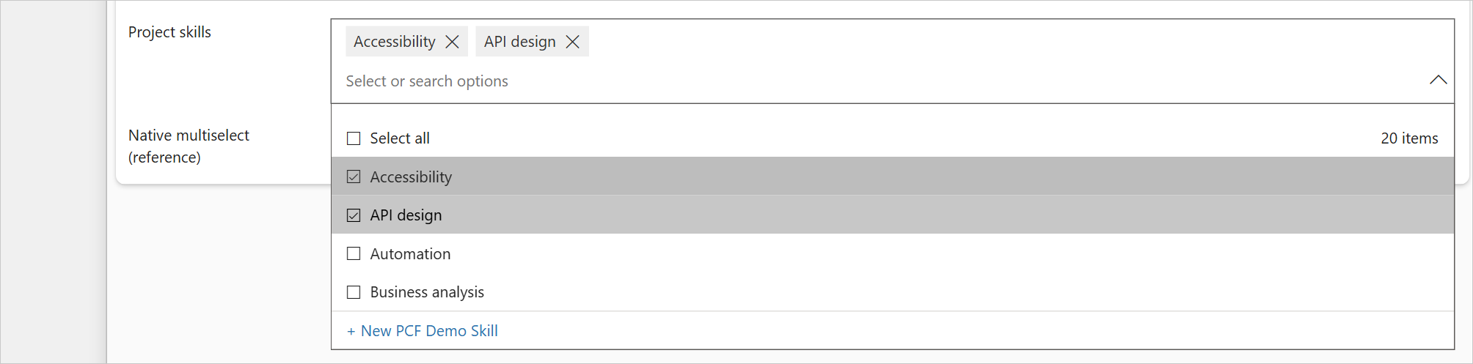
Figure 2. N:N Multi-Select with its list open (Select all turned on).
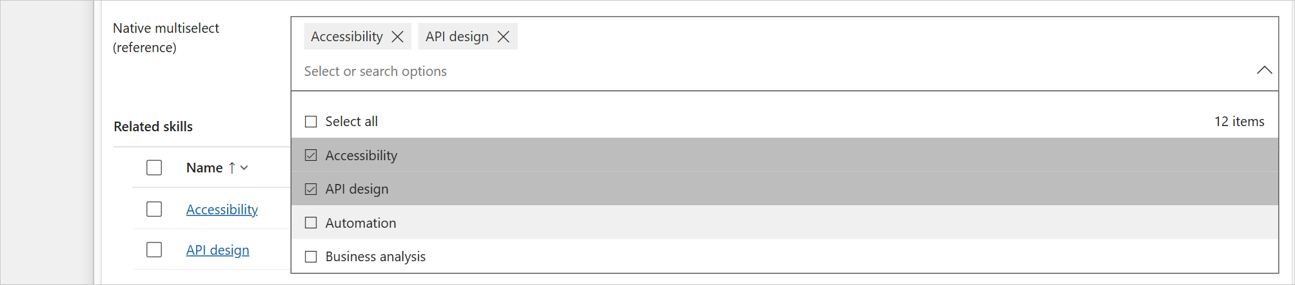
Figure 3. The native multi-select choice column of the same form with its list open, for comparison.

1.3 Comparison with the PCF Gallery N:N control
The N:N Multi-Select control published on PCF Gallery (ITAintBoring) is a widely used control for the same purpose. Both edit a standard many-to-many relationship, so the data model is the same; they differ in how they look, how they are set up and how they save. The table compares the two.
Area | PCF Gallery N:N control | N:N Multi-Select
Look on the form | select2 tag box with its own styling | Same as the native multi-select choice field: chips, a list with check boxes and Select all
Setup | Five properties: linked table, name and id columns, relationship and intersect table names (case-sensitive) | One required property: the relationship schema name (any casing); everything else is read from metadata
Records offered | FetchXML stored in a separate web resource | System view, FetchXML filter or OData filter set on the control
Saving on existing records | A link per click; errors in browser pop-ups | A link per click, with retries, rollback of failed changes and messages under the field
New records | Writes the picks as JSON into the bound column; a separate plug-in reads it after the save and creates the links | Keeps the picks and links them after the first save; no plug-in
Bound column | Overwritten with JSON | Not changed by default; can hold a readable list of names for views
Subgrids | Not refreshed after changes | Refreshed after changes, changes made in them appear in the control, and the control can hide them
Inactive records | Offered like any other record | Hidden by default (configurable)
Select all | No | Yes, with a configurable limit
Large tables | Up to 5,000 rows in one request | 500 rows in memory, then server search with paging
Third-party code | jQuery and select2 | None

Information about the PCF Gallery control describes version 0.0.109 of ItAintBoring.PCFControls.NToNMultiSelect.

2. Package contents

2.1 Files in the package
The package contains two solution files, a text file and this document. Only one of the two solution files is imported into a given environment.
File | What it is | When to use it
NToNMultiSelect_unmanaged.zip | Unmanaged solution with the code component and the form library web resource. | Development environments. After import, the components can be added to other solutions and moved to test and production as part of them.
NToNMultiSelect_managed.zip | Managed solution with the same two components, locked against changes. | Test and production environments, when the control is deployed as a solution of its own.
README.txt | Short description of the package, the exact component names of this build and SHA-256 checksums of the two zip files. | To check the names and that the files arrived intact.
NToNMultiSelect - Technical Reference.docx | This document. | Installation, configuration and support.

To check a file against the checksum in README.txt, run this command in PowerShell in the folder of the file:
Get-FileHash .\NToNMultiSelect_unmanaged.zip -Algorithm SHA256

2.2 Managed or unmanaged
 | Unmanaged | Managed
Intended for | Development environments | Test and production environments
Components | Can be edited and added to other solutions | Locked; owned by this solution
After import | Publish all customizations is required | Live immediately
Upgrade | Import a newer unmanaged package, then publish | Import a newer managed package
Uninstall | Deleting the solution removes only the solution record; the components stay until they are deleted one by one | Deleting the solution removes its components

Recommended path. Import the unmanaged package into the development environment, add the code component (and the form library, if it is used) to the solution that holds the forms, and let that solution carry the control to test and production. Use the managed package only to deploy the control on its own.

2.3 Components in the solution
Component | Type | Purpose
kv_KV.NToNMultiSelect | Custom control (code component) | The field control. It contains the manifest (settings, display names, descriptions) and bundle.js, about 110 KB, which holds all code and styles. The bundle has no external dependencies.
kv_/NToNMultiSelect/formloader.js | Web resource (JavaScript) | Optional form library. It is used only when an environment does not deliver the control's bundle to the form (section 7). It does nothing unless it is added to a form.

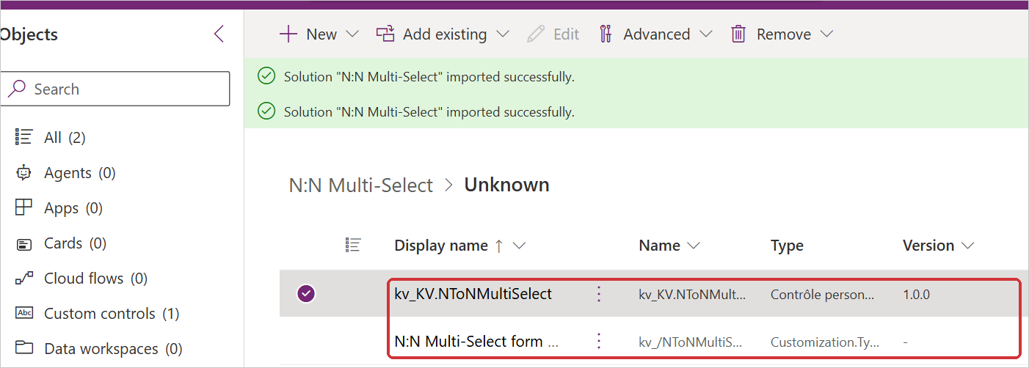
Figure 4. The two components in the solution (Objects).

2.4 Source code
The source code is published as a Git repository under the MIT license: the control is free to use, modify and share, including commercially, provided the copyright notice and the license text are kept with copies of the code. Its layout:
Path | Contents
control/NToNMultiSelect/ControlManifest.Input.xml | Control definition and its settings
control/NToNMultiSelect/index.ts | Controller: settings, loading, saving, new-record handling
control/NToNMultiSelect/src/ | View and styles, Web API client, relationship and metadata access, FetchXML builder, form integration, texts in English and French
formloader/formloader.js | Optional form library
solution/ | Dataverse solution project: publisher, version, form library web resource
scripts/build.mjs | Release build: bundle, both solution packages, checks
dist/ | Built solution packages (attached to each release, not committed)
docs/ | This document

Build requirements: Node.js 20 or later and the .NET SDK 6 or later. The Power Platform CLI is not needed.
cd control
npm ci
cd ..
node scripts/build.mjs

scripts/build.mjs checks the manifest texts (Dataverse rejects apostrophes in them), stamps the control version into the solution and the form library, builds the production bundle, packages the solution with dotnet build -c Release and writes both packages to dist/.

3. Installation

3.1 Before you start
- A security role with the System Customizer or System Administrator privileges in the target environment.
- The solution file for the environment: unmanaged for development, managed for test and production (section 2.2).
- Code components must be allowed in the environment. This is the default for model-driven apps.

3.2 Import the unmanaged solution (development)
- Sign in to make.powerapps.com and select the development environment in the environment picker. In the left navigation, select Solutions (1), then Import solution (2) on the command bar.
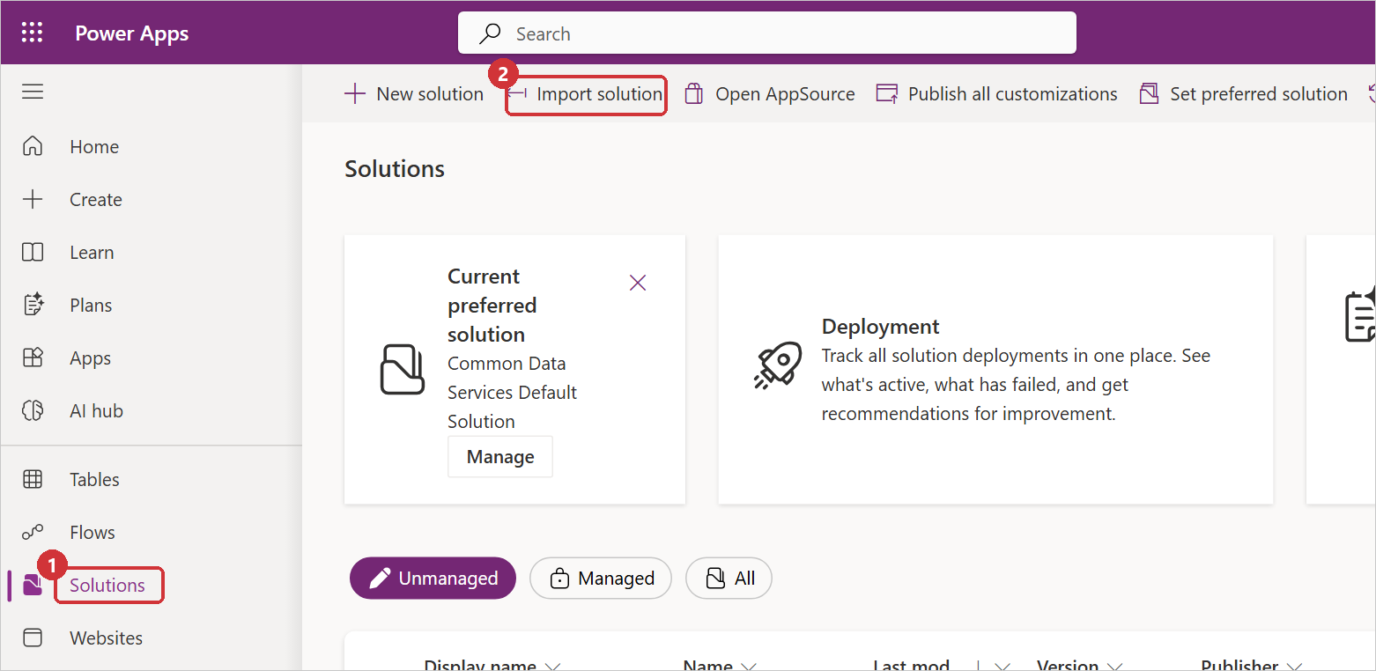
Figure 5. The Solutions page with the Import solution command.
- In the Import a solution panel, select Browse.
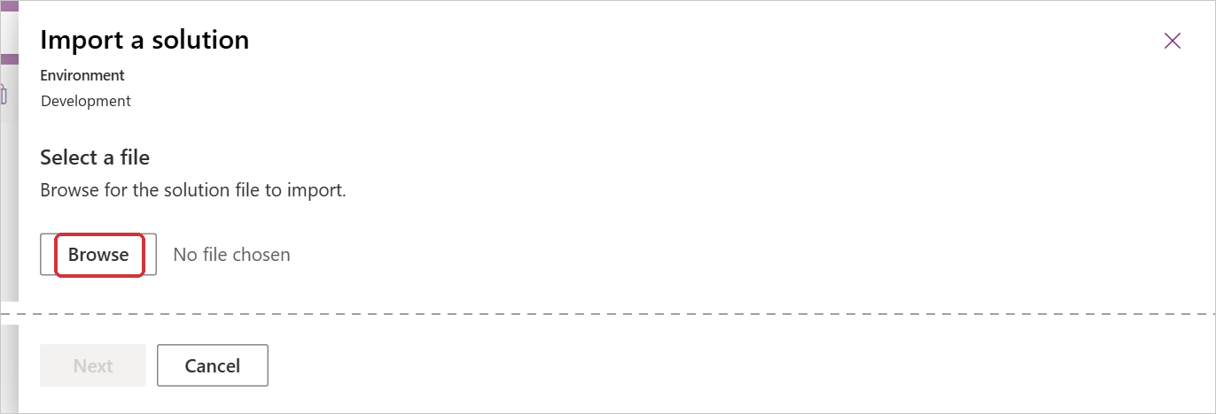
Figure 6. Browse for the solution file.
- Select NToNMultiSelect_unmanaged.zip. The file name appears next to Browse (1). Select Next (2).
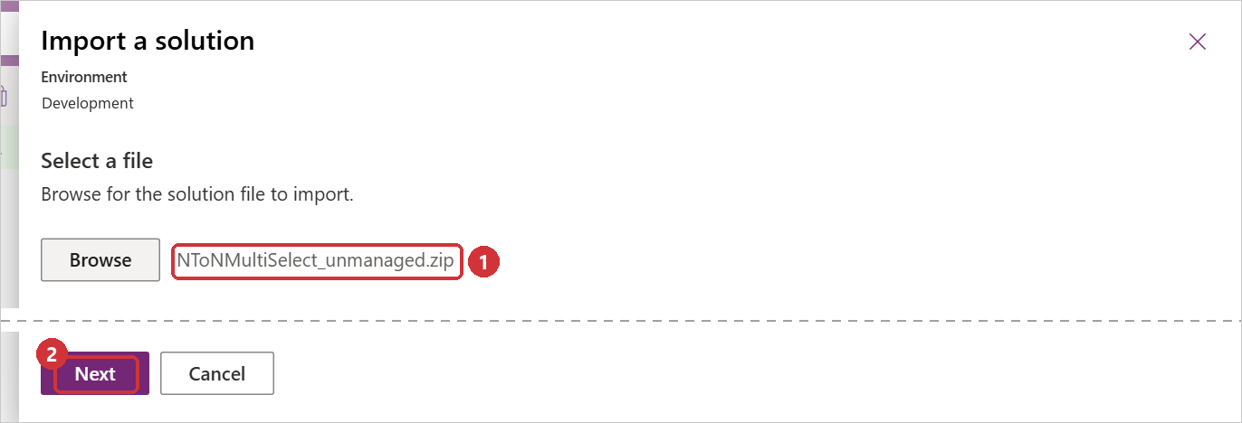
Figure 7. The unmanaged package selected.
- Check the details: Type is Unmanaged (1), the name is NToNMultiSelect and the version 1.0.0.0. Select Import (2). Advanced settings can stay as they are.
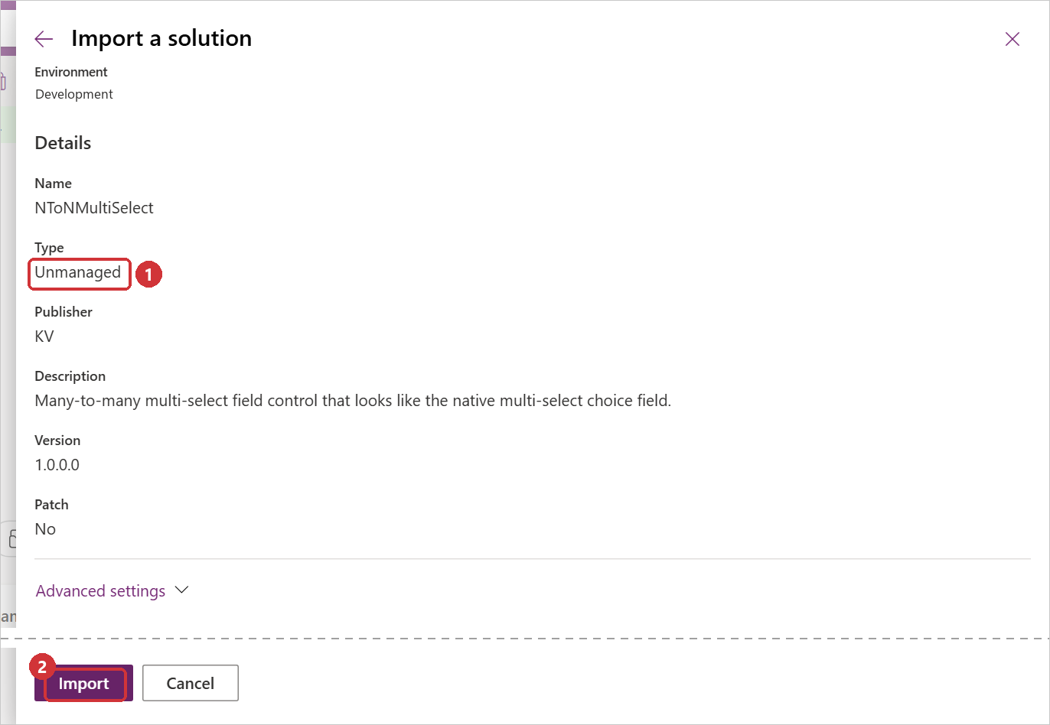
Figure 8. Solution details before the import.
- The import runs in the background. A banner shows its progress.
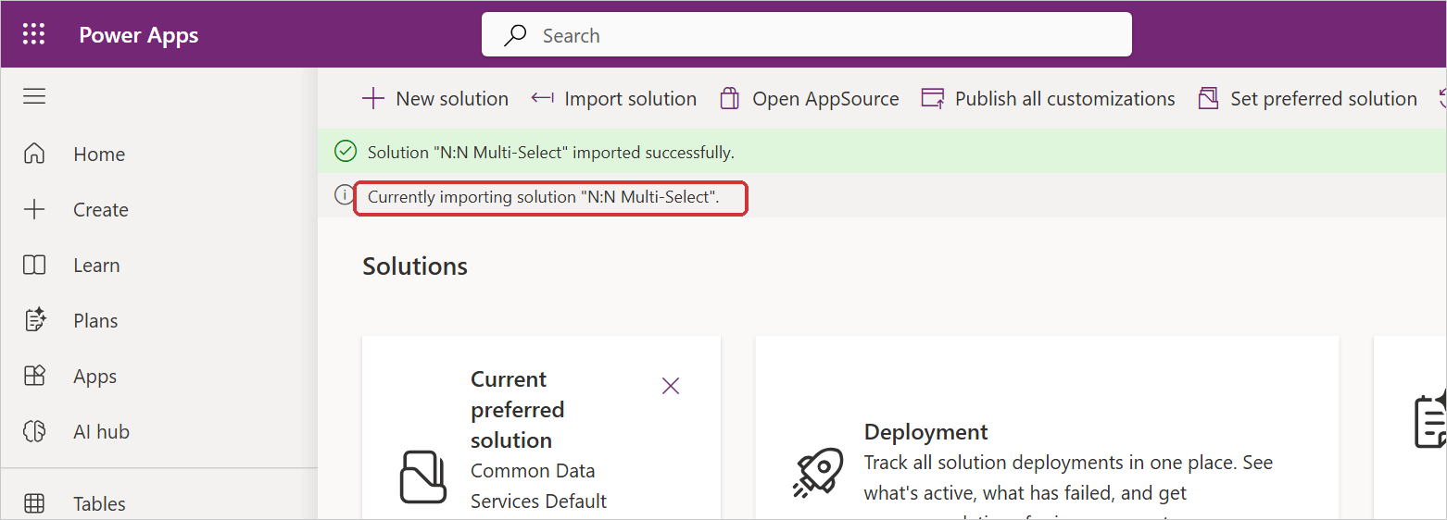
Figure 9. Import in progress.
- When the import has finished, a banner confirms it.
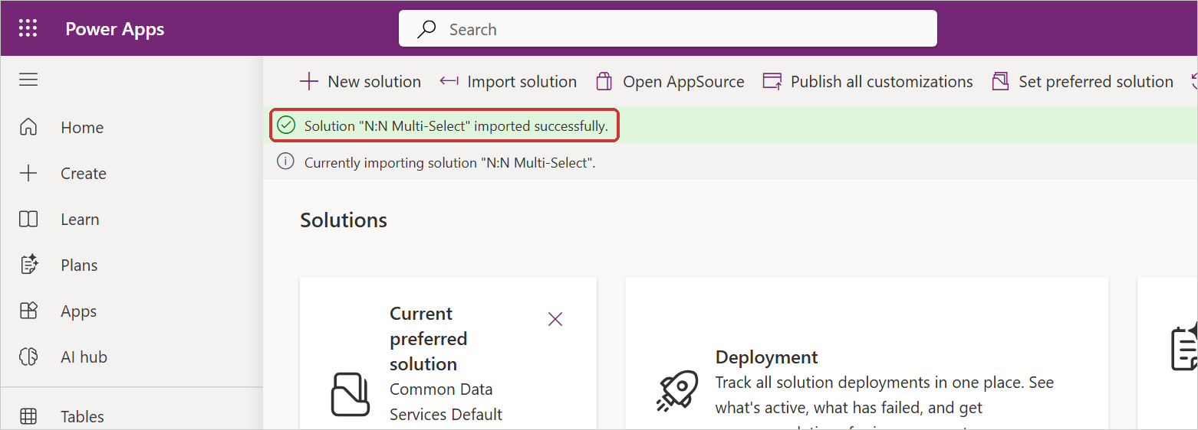
Figure 10. Import finished.
- Select Publish all customizations. Without this step the control is not available in the unmanaged environment.
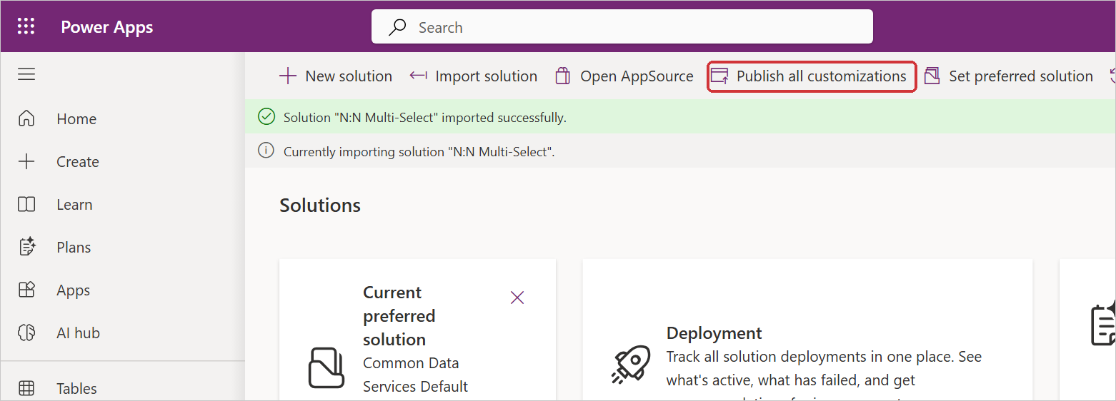
Figure 11. Publish all customizations.
- The solution N:N Multi-Select is listed under Unmanaged.
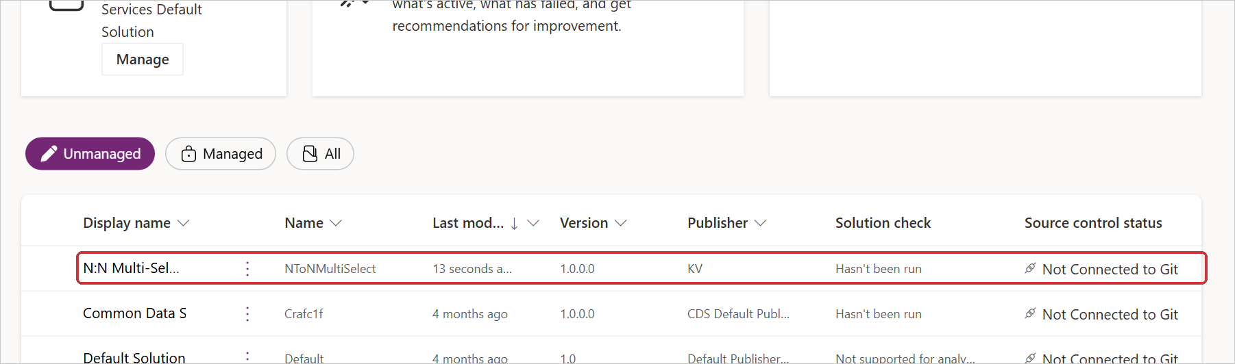
Figure 12. The solution in the list of unmanaged solutions.
One publish at a time. Publish all customizations cannot start while an import is still running. If the message "Cannot start the requested operation [PublishAll] because there is another [Import] running" appears, wait until the import banner disappears and select Publish all customizations again.

3.3 Import the managed solution (test and production)
The steps are the same as for the unmanaged package, with the managed file:
- Select Solutions, then Import solution, then Browse (figures 5 and 6).
- Select NToNMultiSelect_managed.zip (1), then Next (2).
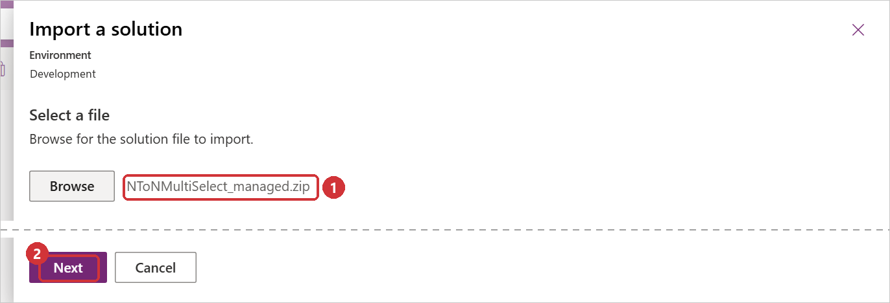
Figure 13. The managed package selected.
- Check that Type is Managed (1), then select Import (2).
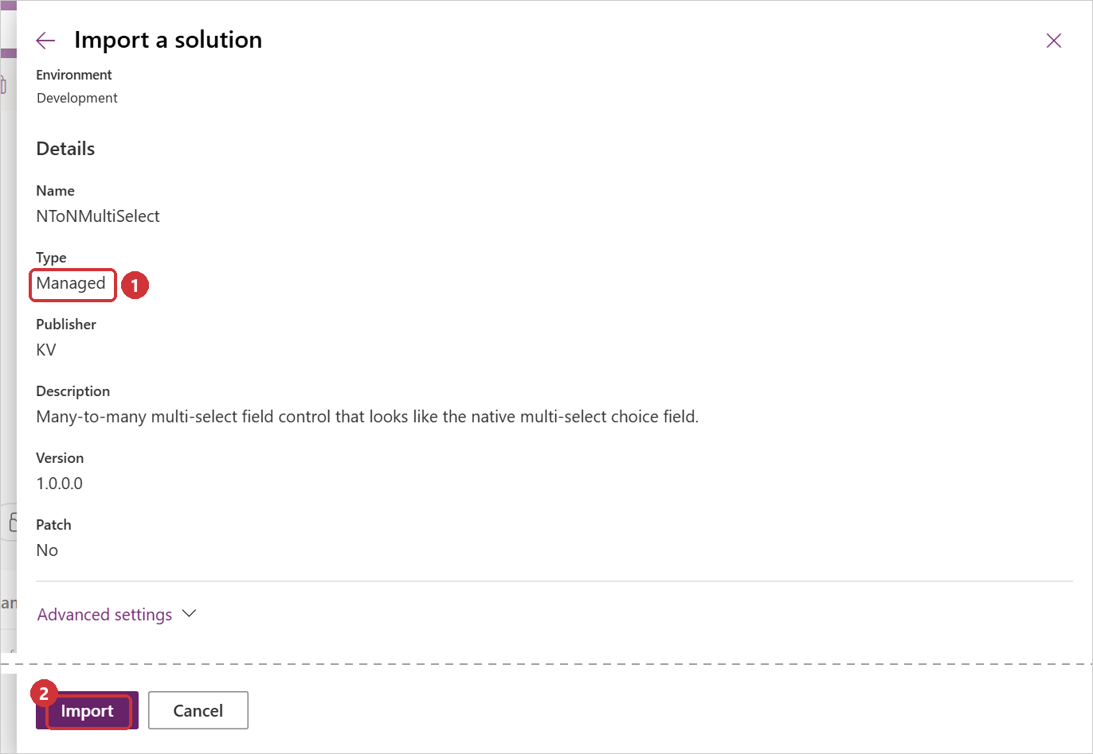
Figure 14. Solution details of the managed package.
- Wait for the confirmation. A managed import does not need Publish all customizations; the components are live when the import finishes.
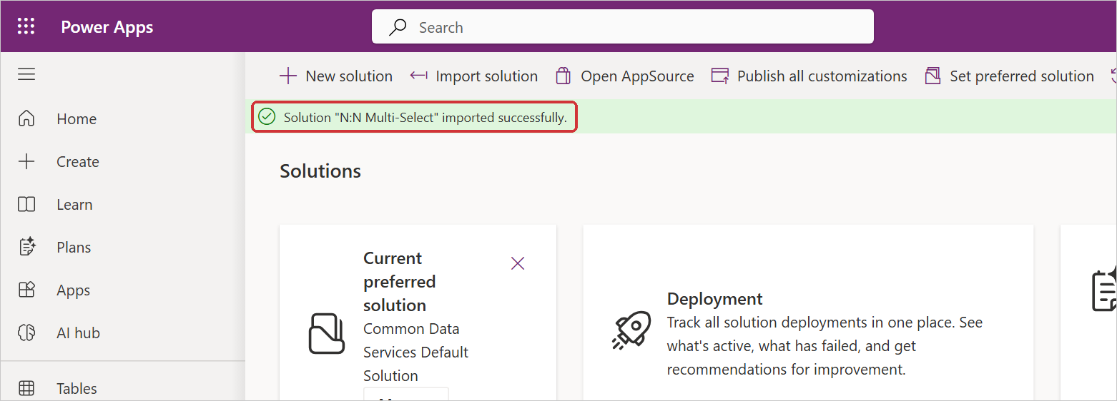
Figure 15. Managed import finished.

3.4 Check the installation
Open the solution from the Solutions list. The overview shows its name, type, publisher and version. Objects lists the code component and the web resource (figure 4).
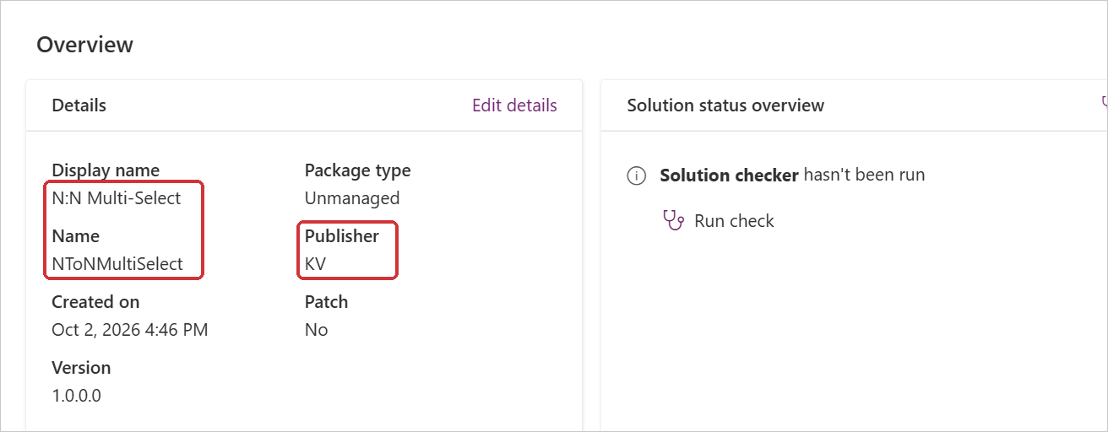
Figure 16. Solution overview: display name, unique name and publisher.

4. Adding the control to a form

4.1 Prepare
Three things are needed before the control can be added:
Item | Where to find it | Example
The many-to-many relationship | Tables → the table of the form → Relationships → the many-to-many relationship → Relationship name (schema name). Any casing works. | ntn_demoproject_ntn_demoskill
A host column | A text column of the form's table (Single line of text, Text area or Multiple lines of text) that is not Business required. A new single line of text column, used only for this control, is the safest choice. | Project skills (ntn_relationshippicker)
Optional: a view of the related table | Tables → the related table → Views. Note the view's id in multilingual environments (section 5.4). | Active PCF Demo Skills

Why the host column must not be required. The control is bound to the host column only as an anchor and never sets its value on the form. A Business required host column would therefore block every save of the form. When Copy names into the host column is used, give the column room for all the names, for example 4,000 characters.

4.2 Add the control in the form designer
- Open the table's main form in the form designer. Add the host column to the form if it is not there yet, and select it on the form.
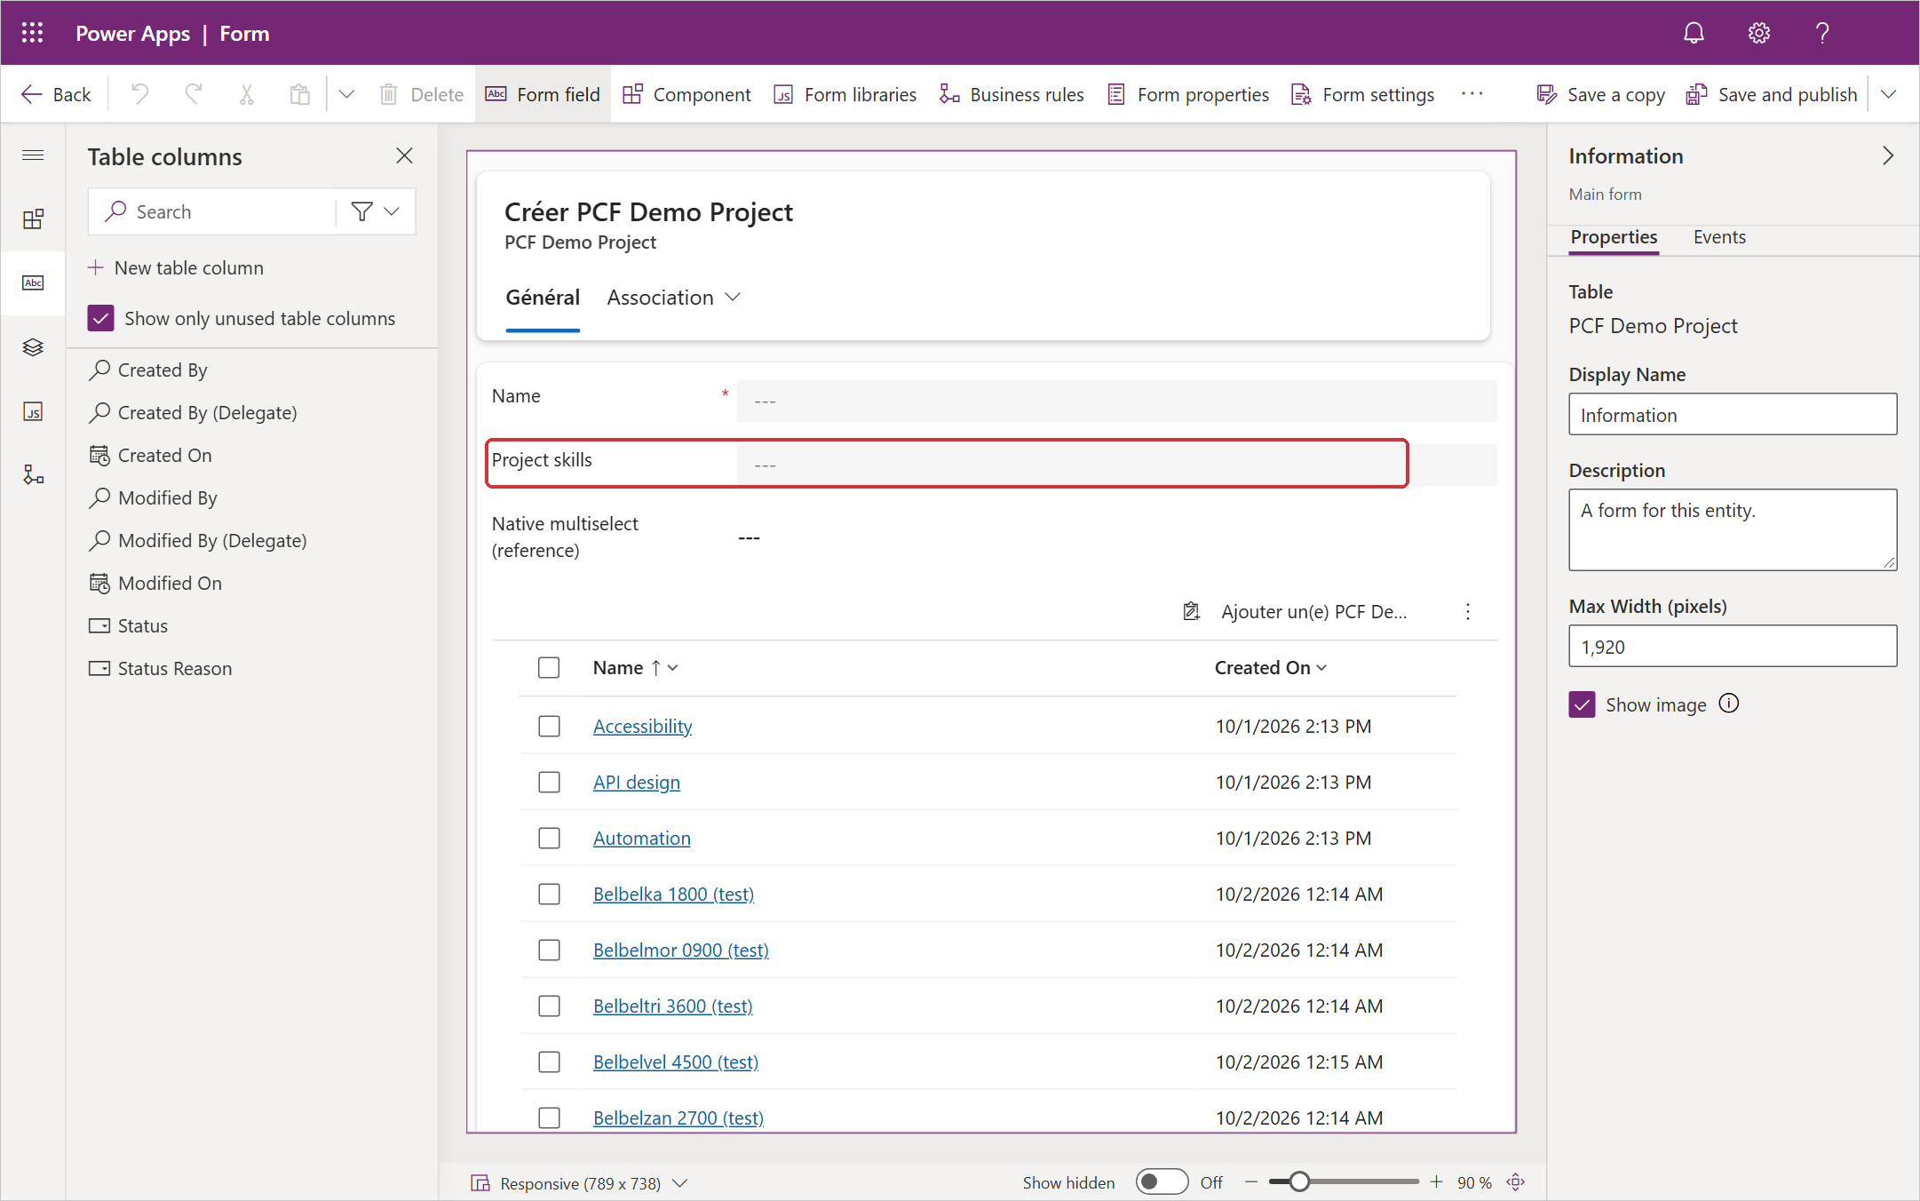
Figure 17. The host column selected on the form.
- In the properties pane on the right, under Components, select + Component.
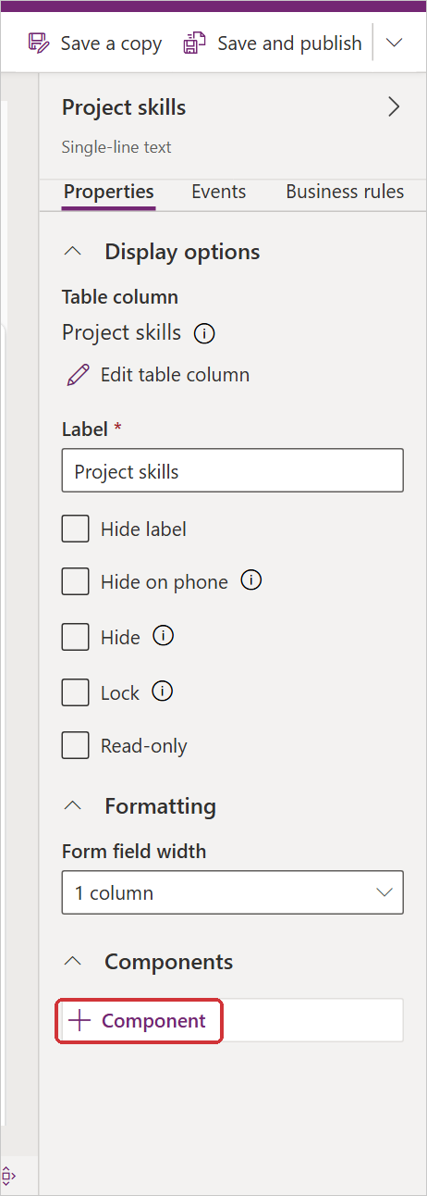
Figure 18. The Components section of the column's properties.
- In the Add component panel, select N:N Multi-Select (1). When the control is not listed, select Get more components (2).
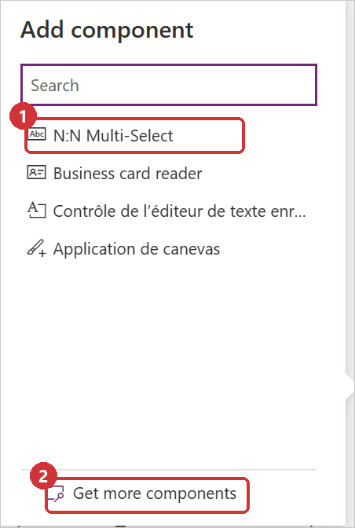
Figure 19. The Add component panel.
- Only after Get more components: select N:N Multi-Select in the list (1), then Add (2). The control is then listed in the Add component panel; select it.
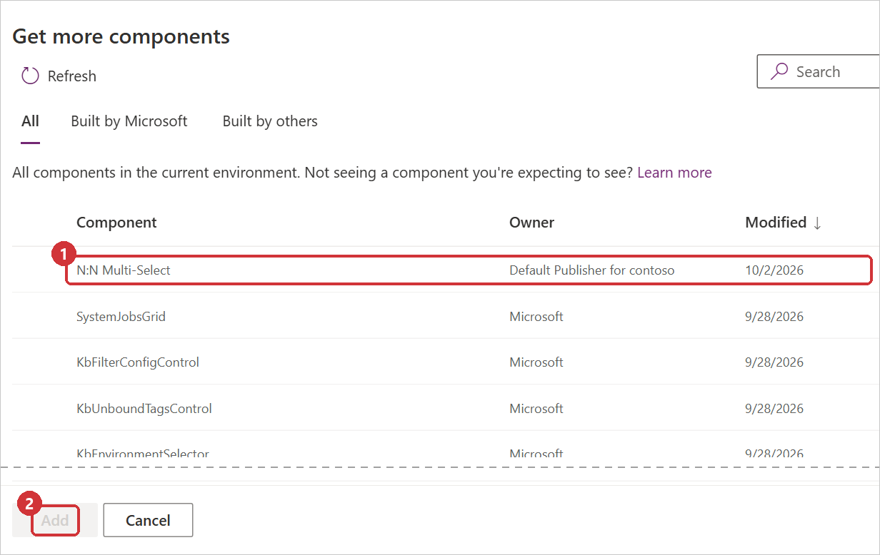
Figure 20. Get more components.
- The settings panel opens. Enter the N:N relationship schema name under Static value. Leave Bind to table column cleared. Fill in the optional settings that are needed (section 5), choose the clients under Show component on (Web, Mobile, Tablet), then select Done.
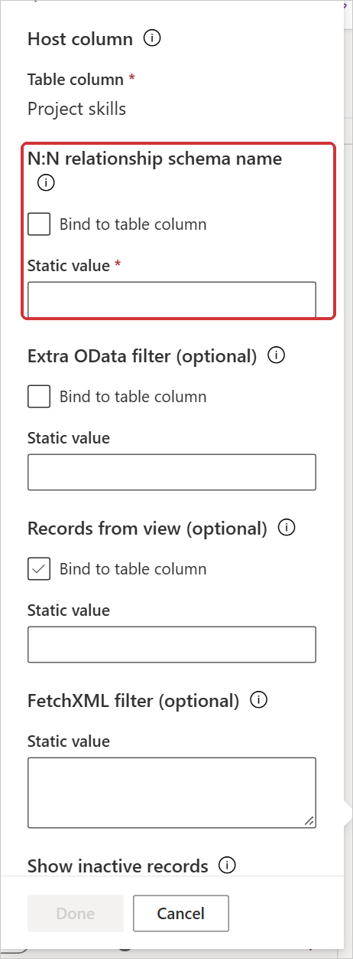
Figure 21. The settings panel: the relationship schema name is the only required setting.
- The control is listed under Components, together with the clients it is shown on.
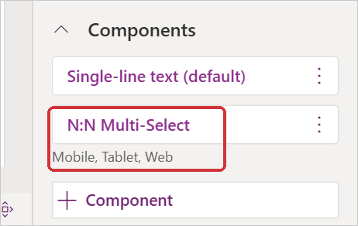
Figure 22. N:N Multi-Select added to the column.
- Select Save and publish.
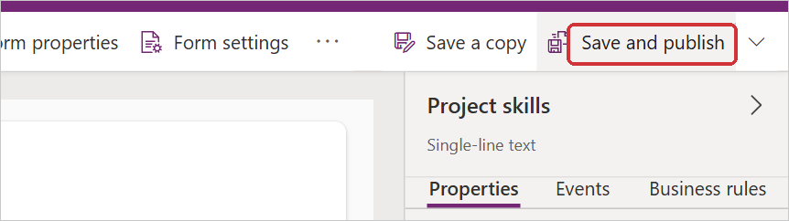
Figure 23. Save and publish the form.
- Open a record of the table in the app. The field shows the control (figure 1). If the field shows "Error loading control" instead, add the form library (section 7).

4.3 Example configuration
The screenshots in this document use this configuration on the PCF Demo Project main form:
Setting | Value
Host column | Project skills (ntn_relationshippicker, single line of text)
N:N relationship schema name | ntn_demoproject_ntn_demoskill
Records from view | Active PCF Demo Skills
FetchXML filter | <filter><condition attribute="ntn_name" operator="not-like" value="%(test)" /></filter>
Show Select all | No (Yes in figure 2)
Copy names into the host column | Yes
Open selected records | Yes
Show + New button | Yes (the button appears only when quick create is enabled for the related table)
Other settings | Default

Figures 37 to 40 were taken without the FetchXML filter, so that the list draws on more than 5,000 records.

5. Settings reference
All settings are entered in the control's settings panel in the form designer (figure 24). Each setting has a tooltip with the same description as this section.
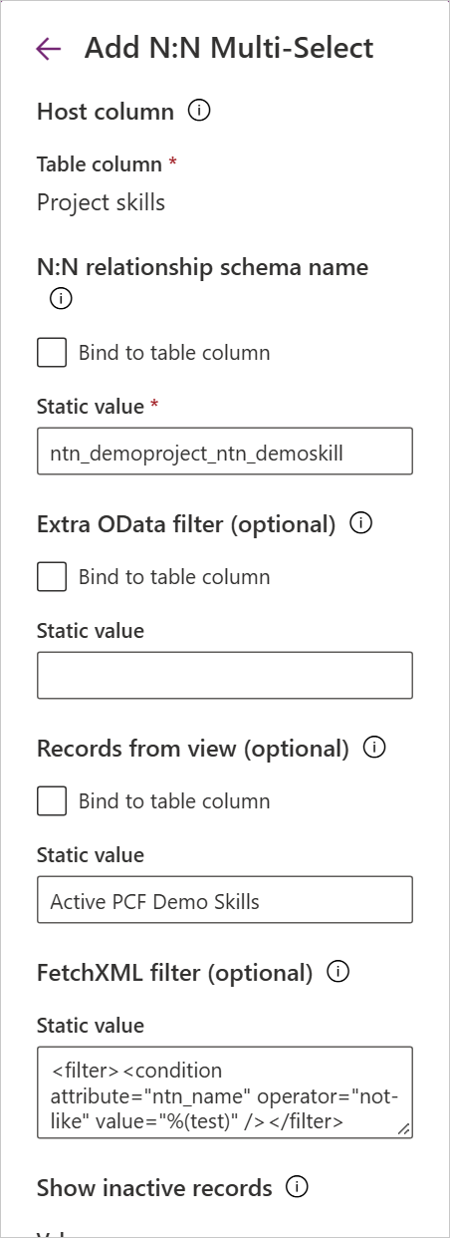 | 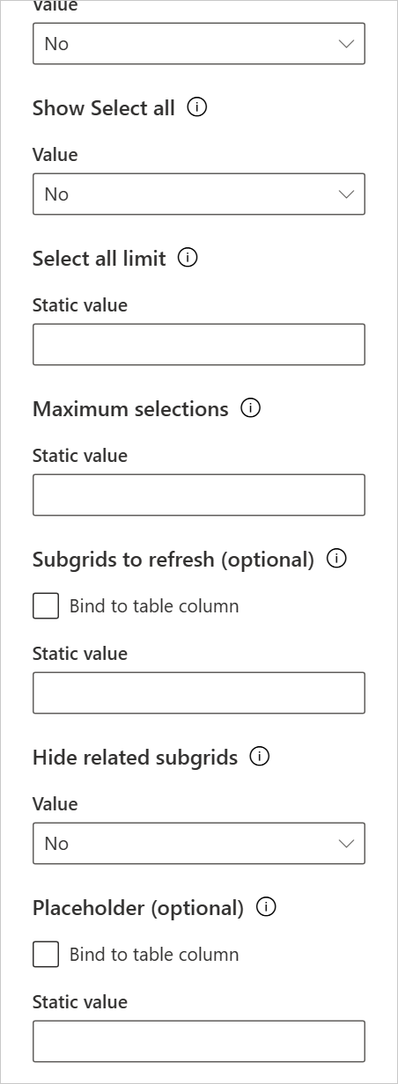 | 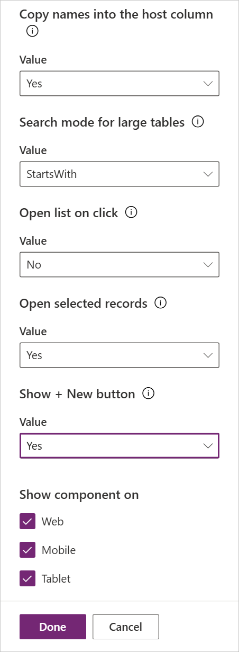
Figure 24. The complete settings panel, in three parts (top to bottom, left to right).

5.1 Static value and Bind to table column
Every single-line text setting offers Bind to table column (FetchXML filter takes a static value only). Leave it cleared and type the value under Static value; that value applies to every record. When the box is ticked, the setting is read from a column of the record instead, so it can differ per record. This is rarely needed. The control reloads its list when a bound value changes while the form is open.

5.2 All settings
Setting | Default | Description
Host column | (required) | The text column the control is placed on. Used only as an anchor; it must not be Business required.
N:N relationship schema name | (required) | The relationship to edit, for example new_project_skill. Not case-sensitive. The related table, its name column and the navigation properties are found automatically.
Extra OData filter (optional) | Empty | Limits the records that can be selected, for example new_category eq 2. Applied together with the active-records filter. Cannot be combined with a view or a FetchXML filter.
Records from view (optional) | Empty | Name or id of a system view of the related table. Only records the view returns can be selected. Only the view's filters are used; its columns and sort order are ignored. Use the id in multilingual environments.
FetchXML filter (optional) | Empty | <filter> and <link-entity> elements added to the query (and to the view, if one is set), or a complete <fetch> query of the related table.
Show inactive records | No | Yes also offers inactive records. Ignored when a view or a complete FetchXML query is set.
Show Select all | Yes | Shows the Select all row at the top of the list, as in the native control.
Select all limit | 100 | Select all is offered only when the list holds at most this many records. Maximum 500; 0 means 500. Each record is linked with its own request.
Maximum selections | 0 (no limit) | The most records that can be selected in this control. Further rows are greyed out with a note. Subgrids and integrations are not limited.
Subgrids to refresh (optional) | Empty | Comma-separated names of the subgrids to keep in sync. Empty: every subgrid on the form that shows the same relationship. none: no syncing.
Hide related subgrids | No | Yes hides the subgrids the control replaces (the ones listed in Subgrids to refresh, or all subgrids of the same relationship).
Placeholder (optional) | Select or search options | Text in the empty search box.
Copy names into the host column | No | Yes writes the selected names, for example "API design; Automation", into the host column of the record after each change, for views, search and exports (section 5.6).
Search mode for large tables | Starts with | For related tables with more than 500 records: Starts with (fast on any size) or Contains (matches anywhere, slower on very large tables).
Open list on click | No | No: as in the native control, a click focuses the box and the list opens from the chevron, the Down arrow key, Enter or typing. Yes: a click anywhere in the box opens the list.
Open selected records | No | Yes turns each selected value into a link that opens the record in a new browser tab (section 5.7).
Show + New button | No | Yes adds a + New button at the end of the list that opens the related table's quick create form (section 5.8).
Show component on | Web, Mobile, Tablet | The clients that use the control. Clients that are cleared show the plain text column.

5.3 Which records can be selected
By default every active record of the related table can be selected. Three settings narrow this down:
- Records from view: the list shows what a system view of the related table shows. Only the view's filters are used, including filters on related tables. The list is always sorted by name.
- FetchXML filter: <filter> and <link-entity> elements, added with AND to the view (or to a query of the related table that follows Show inactive records), or a complete <fetch> query that decides on its own. A complete query cannot be combined with a view.
- Extra OData filter: a simple condition on the related table's own columns. It cannot be combined with a view or a FetchXML filter; put the condition in the FetchXML filter instead.
Example: offer only the records where a choice column new_kind has the value 1:
<filter>
<condition attribute="new_kind" operator="eq" value="1" />
</filter>

Records that are already linked but no longer match still show as selected and can be removed; they are only left out of the list. Settings that cannot work, such as a view that does not exist or FetchXML for another table, are explained in the list and in the browser console.

5.4 Views in multilingual environments
View names can be translated, so a name that works for one user can fail for a user who works in another language. Enter the view's id instead. To list the views of a table with their ids, open this address in the browser (replace the environment address and the table's logical name):
https://<environment>.crm.dynamics.com/api/data/v9.2/savedqueries?$select=name&$filter=returnedtypecode eq '<table>'

Each view is listed with its savedqueryid. When a translated name is entered, the control's message also gives the id to use. The control reads a view's definition once per page load; reload the app after changing the view.

5.5 Subgrids
After a change is saved, and the user pauses for about half a second, each related subgrid on the form is refreshed once. Links added or removed in a subgrid appear in the control. With Hide related subgrids, the control hides those subgrids when it starts. The control does not need the subgrid, so it can also be removed from the form, or Visible by default cleared in its properties; this avoids the grid showing briefly while the form loads.
When a record is opened in a dialog or a side pane, the control still saves every change, but it leaves the subgrids of that form alone (no refresh, no hiding): the platform's form API there describes the page underneath.

5.6 Copy names into the host column
With this setting, the control writes the selected names, sorted and separated by "; ", into the host column of the record after each saved change, with an update of its own. The column can then be added to views, searched and exported.
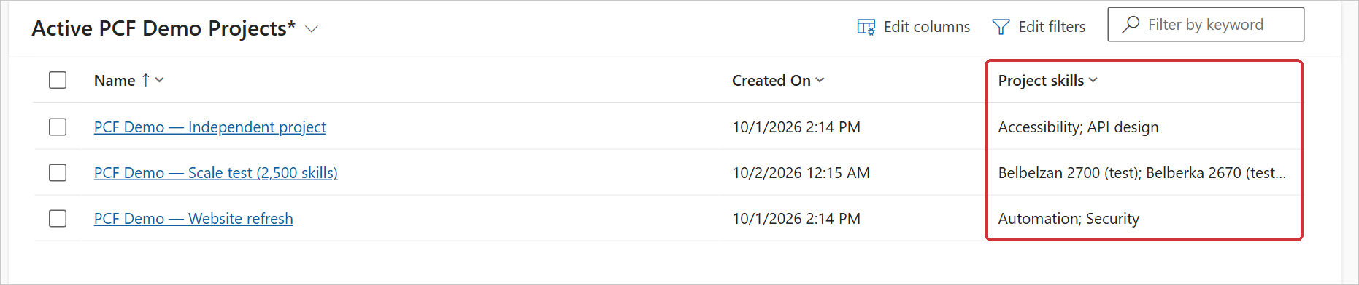
Figure 25. A view with the host column (Project skills) filled by Copy names into the host column.
- The form is not made dirty. Plug-ins, flows and auditing see the update, and the user needs Write permission on the record.
- The text is cut to the maximum length of the host column.
- The copy follows changes made with this control and with subgrids on the same form. Changes made elsewhere (imports, integrations, the other side of the relationship) are not copied. Records linked before the setting was turned on keep their old value until their selection changes; fill them once with a flow or a script when the setting goes live. For a column that must always be exact, use a plug-in on Associate and Disassociate instead.
- Anyone who can read the record can read the copied names, including users who cannot see the related records themselves. When the related table holds restricted records, leave the setting off or protect the host column with column security.

5.7 Open selected records
Each selected value becomes a link that opens the record in a new browser tab. Ctrl+click and middle-click work as for any link. With the keyboard, press Backspace in the empty search box, move between the values with the Left and Right arrow keys and press Enter. The links also work when the field is read-only. In the mobile app, the record opens in the app.
Figure 26. With Open selected records, the values are links (the pointer is on Accessibility).

5.8 Show + New button
The list ends with a + New button that opens the quick create form of the related table, so a missing record can be created without leaving the form. The button appears when quick create is enabled for the related table, and is hidden while Maximum selections is reached. To set the table up:
- Tables → the related table → Properties → Advanced options → tick Leverage quick create form if available.
- Tables → the related table → Forms: give the table an active form of type Quick Create with the columns a new record needs (at least the required ones).
- Publish the table.
- Open the list and select + New <related table> at the end of the list.
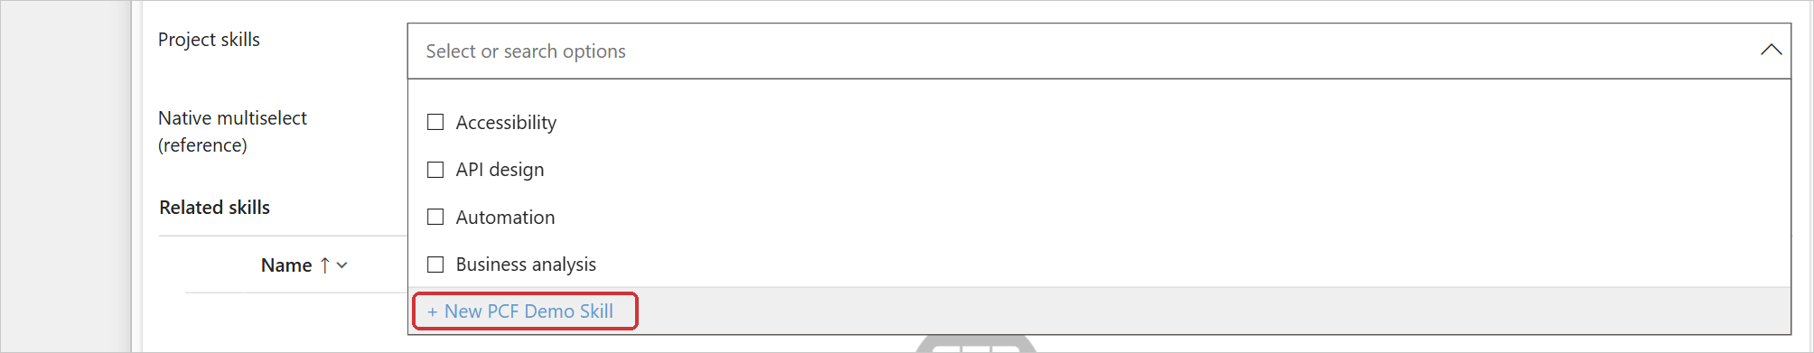
Figure 27. The + New button at the end of the list.
- Fill in the quick create form and select Save and Close.
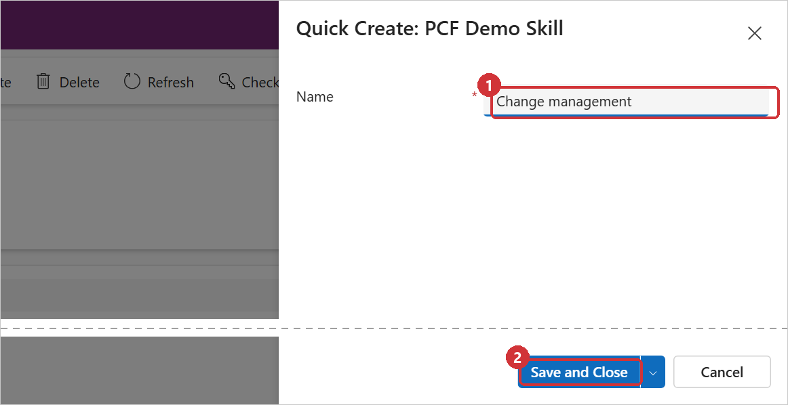
Figure 28. The quick create form of the related table.
- The new record is selected and linked straight away.
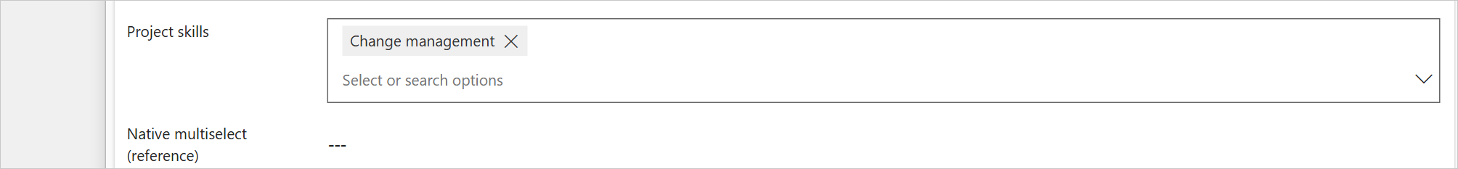
Figure 29. The new record selected in the field.
The new record is selected only when the list offers it: it must be active and match the view and filters of the field. Otherwise the record is created but not selected, and a message under the field explains why.

6. Using the control

6.1 States of the field
State | What the user sees
Idle | The selected names in bold, separated by commas ("---" when nothing is selected).
Pointer over the field | A grey border; the values become chips with an × to remove them.
Focused | The chips, a "Select or search options" box and a chevron. The list opens from the chevron, the Down arrow key, Enter or typing.
List open | Optional Select all row with the number of items, then one row per record with a check box. Selected rows are grey. Typing filters the list.
Read-only | A grey box with the names. With Open selected records, the names are links.

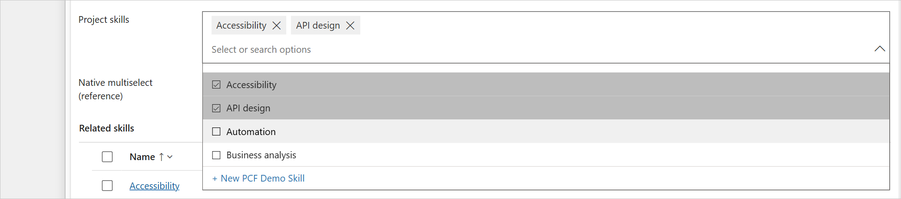
Figure 30. The list open. Selected rows are grey; the pointer is on Automation.
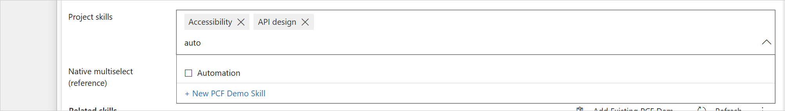
Figure 31. Typing filters the list ("auto" finds Automation). The search ignores case and accents.
Figure 32. Read-only field (lock icon). With Open selected records the names are links.

6.2 Selecting and removing records
A click on a row selects or removes the record and saves the change at once. Rows and values that are being saved are dimmed until the server confirms the change. If a change fails, it is undone and a message under the field gives the reason; other changes carry on, except after a connection, permission, timeout or throttling error, when the changes not yet sent are undone as well. The subgrid of the same relationship is refreshed after the changes.
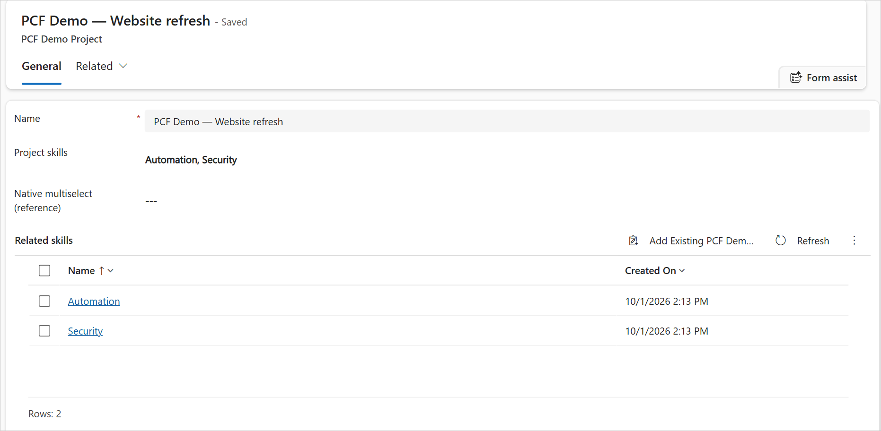
Figure 33. Two records picked on a saved record: the control and the subgrid show the same links, and the form stays saved.

6.3 New records
On a record that has not been saved yet, picks are kept and a note under the field says that they are linked when the record is saved. They are linked after the first successful save, also with Save & Close. If the save is blocked, nothing is linked and the picks stay until the save succeeds. On a quick create form, on a new record opened in a dialog or side pane, and on new Appointment, Recurring Appointment and Service Activity records, the save cannot be followed safely; there the control asks for the record to be saved first.
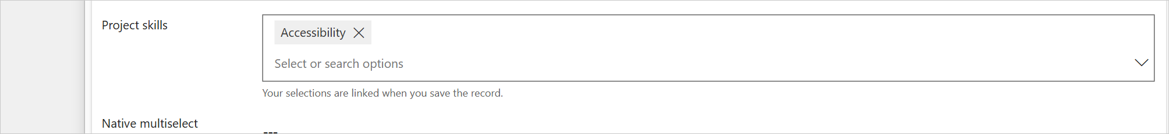
Figure 34. A new record: the pick is held until the record is saved.

6.4 Many values
The field keeps a single line, like the native control. Values that do not fit are counted in a "+N" button; it expands the field to show all values, and "less" collapses it again. The demonstration record below has 2,499 links.
Figure 35. A record with 2,499 linked records: one line and a "+2494" button.
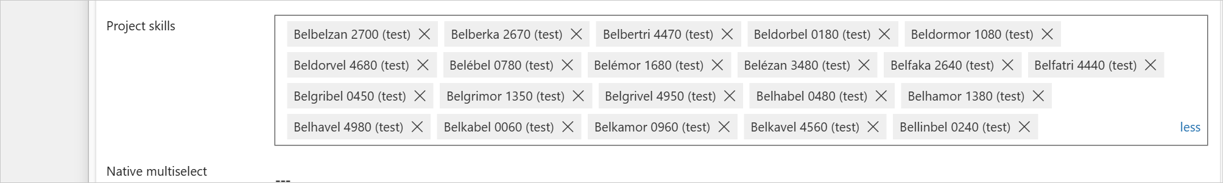
Figure 36. Expanded: the values scroll inside the field, and "less" collapses it.

6.5 Large lists
Lists of up to 500 records are loaded at once, filtered in the browser as the user types, and match the text anywhere in the name. When the related table (after the view and filters) has more than 500 matching records, the control works with the server instead:
- The list shows the first 500 records. Scrolling near the end shows a Loading… row while the next 500 are fetched, and so on.
- Typing searches on the server. With the default Search mode for large tables (Starts with), the text is matched at the start of the name, which is fast on tables of any size; Contains matches anywhere in the name.
- Select all is offered only when every matching record is loaded and their number is within the Select all limit.
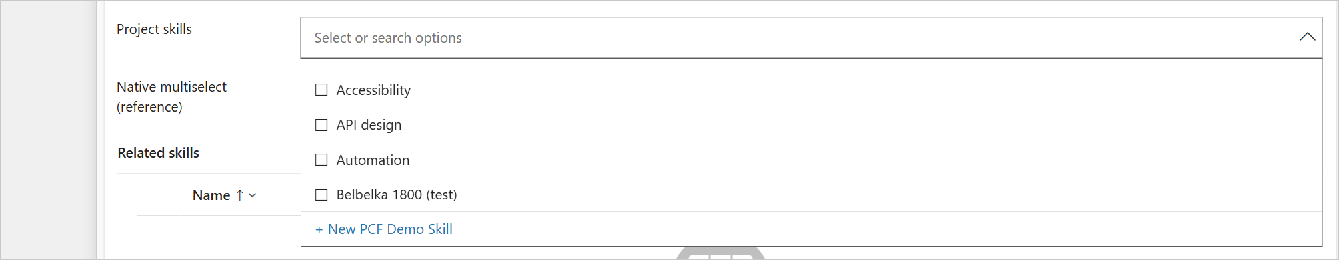
Figure 37. A related table with more than 5,000 records: the first 500 are listed.
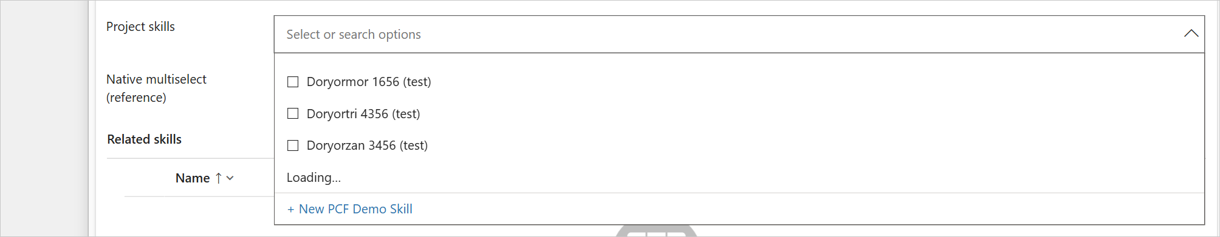
Figure 38. Scrolling to the end of the loaded records fetches the next 500 (Loading…).
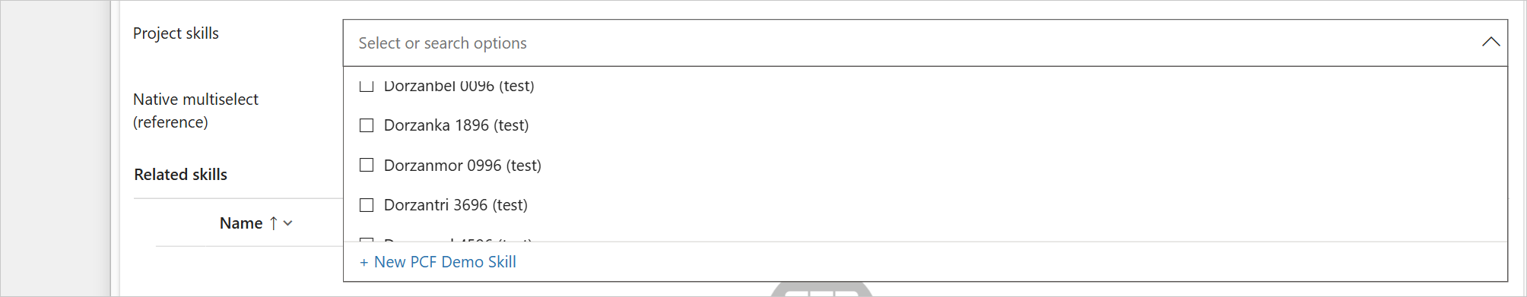
Figure 39. The next records are added to the list.
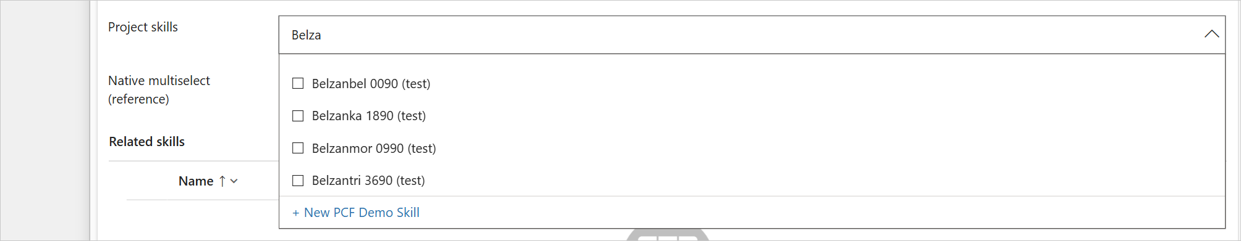
Figure 40. Typing "Belza" searches on the server (Starts with).

6.6 Select all and hidden subgrid
With Show Select all, the first row selects or removes every record in the list (up to the Select all limit). With Hide related subgrids, the subgrid of the relationship is not shown.
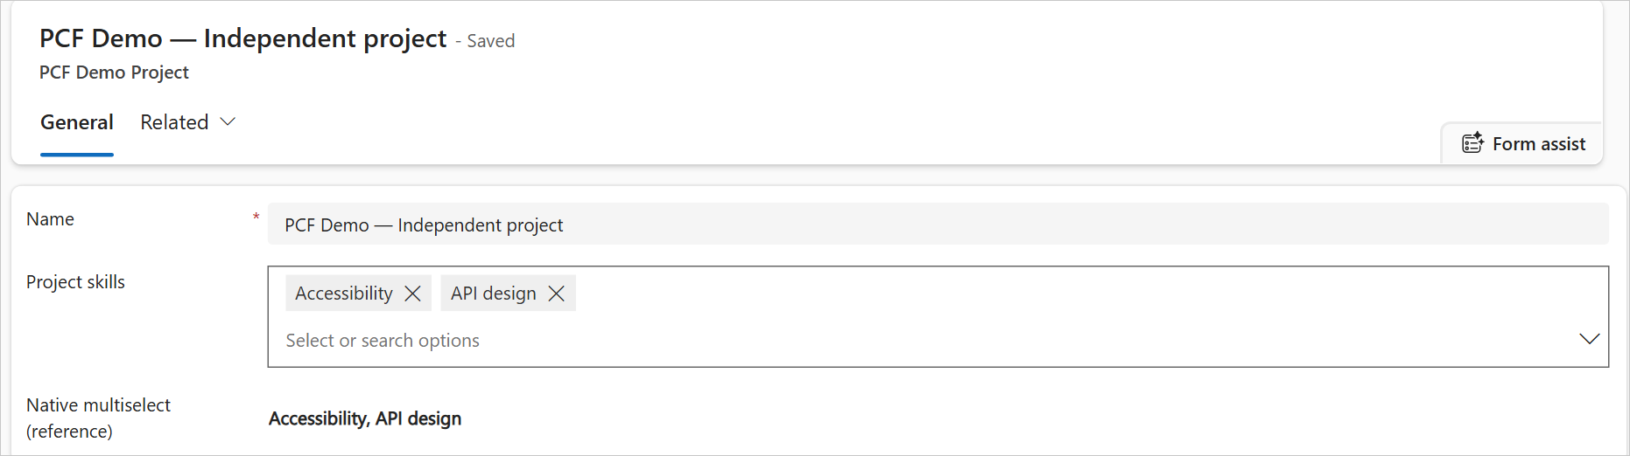
Figure 41. Hide related subgrids: the PCF Demo Skills subgrid is hidden and the control replaces it.

6.7 Keyboard
Key | Action
Down arrow, Alt+Down arrow | Opens the list with the first row highlighted
Up and Down arrows, Page Up, Page Down, Ctrl+Home, Ctrl+End | Move the highlight in the list
Enter | Opens the list, or selects or removes the highlighted row
Escape | Closes the list, then clears the search text
Typing | Opens the list and filters it
Backspace in the empty search box | Moves the highlight onto the selected values
Left and Right arrows (on the values) | Move between the values
Delete or Backspace (on a value) | Removes the value
Enter (on a value) | Opens the record in a new tab (with Open selected records)
Tab | Leaves the field

Screen readers announce the field as a combo box with a list of options, and announce each change.

6.8 Touch
On phones and tablets a tap on the field focuses it and shows the values as chips, without removing or opening anything. Further taps then work on the chips: the × removes a value, and with Open selected records a tap on a name opens its record.

6.9 Messages
The control explains every problem in the user's language. Problems with a change appear under the field in red, with Dismiss. Problems with the list appear in the list, including a view, FetchXML filter or Extra OData filter that cannot work. A missing or wrong relationship name appears in the field itself. A change that fails is undone, so the field always shows what is saved. Appendix A lists every text the control shows, in English and French.
The failures in the screenshots below were produced on purpose in the development environment.
Figure 42. Note: picks on a new record are held until the record is saved.
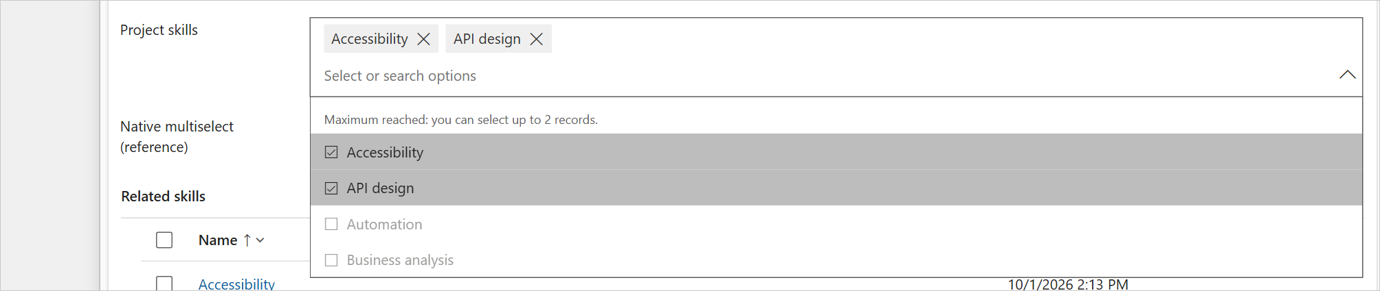
Figure 43. Note: Maximum selections reached; the other rows are greyed out.
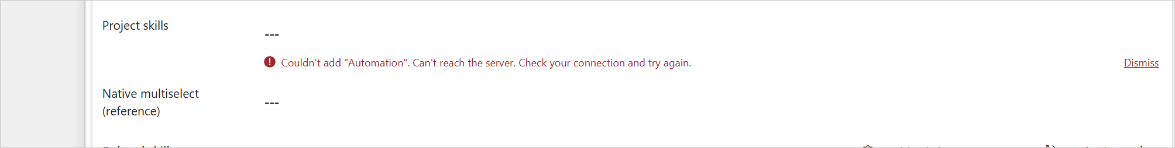
Figure 44. The connection was lost while saving a pick; the pick is undone.
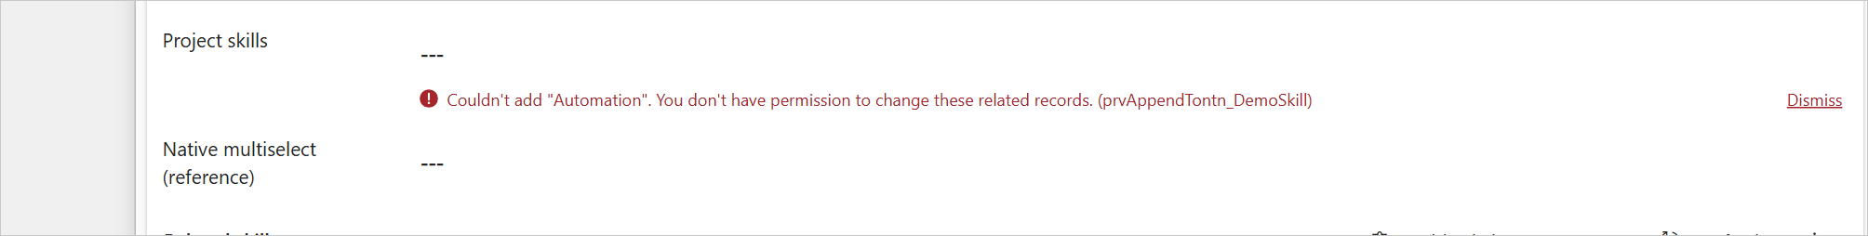
Figure 45. The user's security role lacks a privilege; its name is given in brackets.
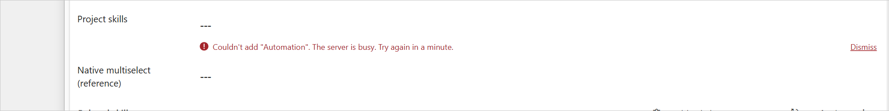
Figure 46. Dataverse throttled the user (service protection limits) after the control's retries.
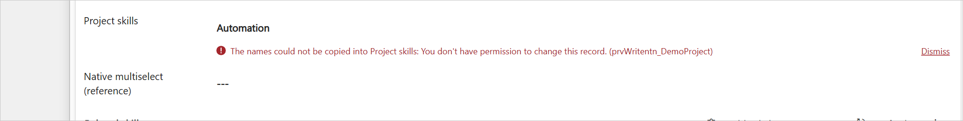
Figure 47. The link was saved, but Copy names into the host column could not update the record.
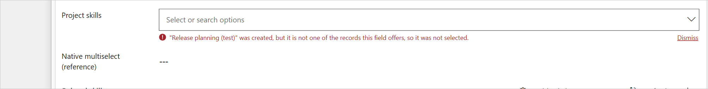
Figure 48. A record made with + New does not match the list's filters, so it is not selected.
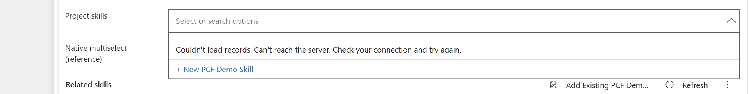
Figure 49. The list could not be loaded.
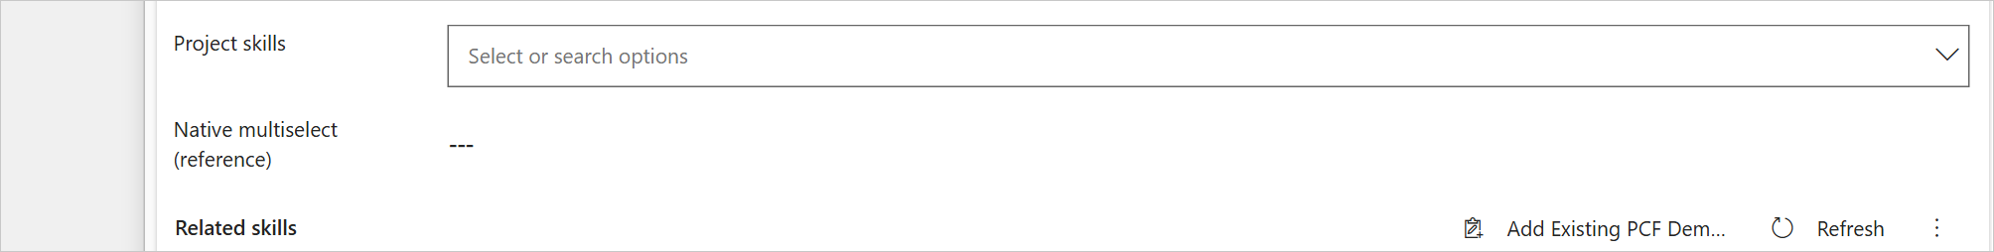
Figure 50. The user's session expired; the page has to be refreshed.
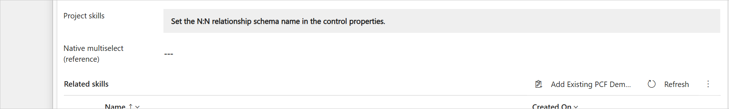
Figure 51. Setting error: the relationship schema name is empty.
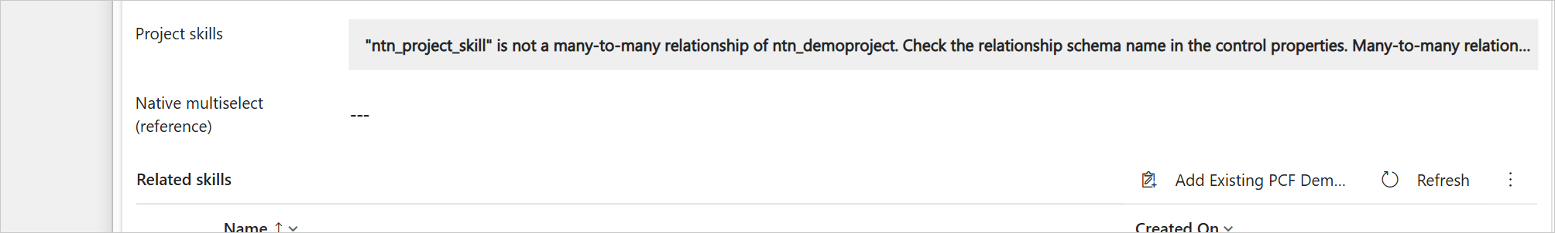
Figure 52. Setting error: the relationship schema name is wrong (the message lists the valid names).
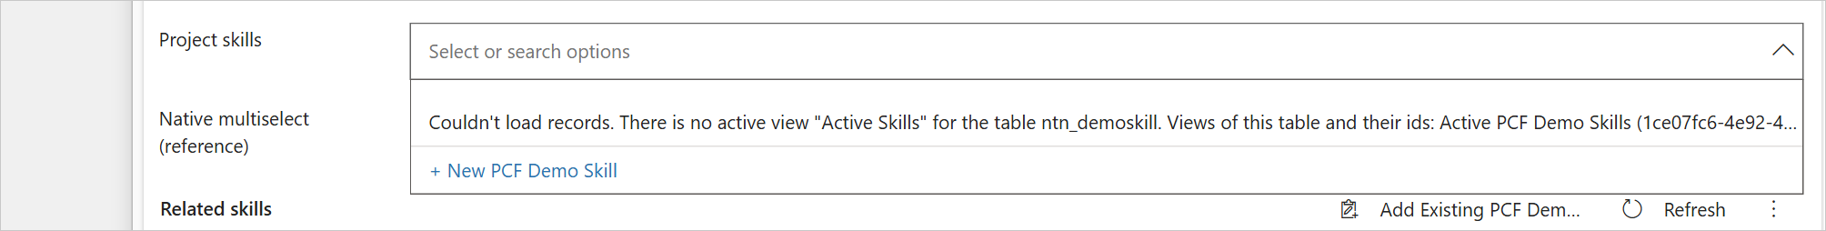
Figure 53. Setting error: Records from view names a view that does not exist (the message lists the views and their ids).
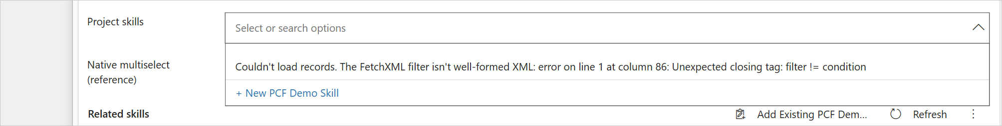
Figure 54. Setting error: the FetchXML filter is not valid XML.
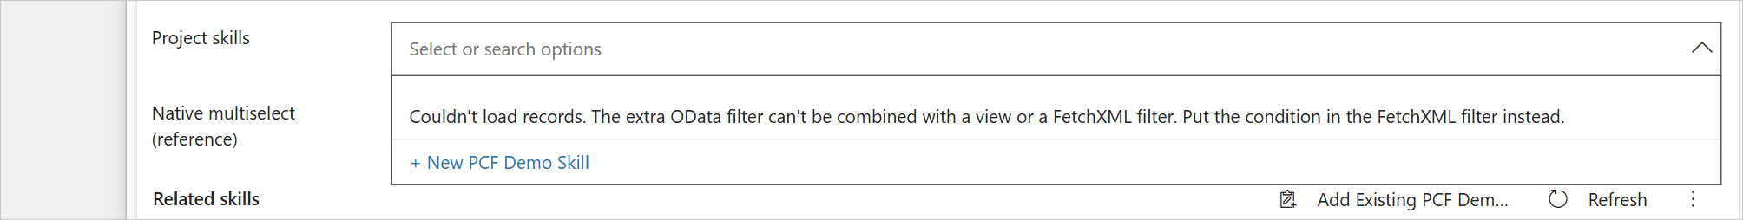
Figure 55. Setting error: an Extra OData filter combined with a view.
Details are written to the browser console with the prefix [KV.NToNMultiSelect].

7. The form library

7.1 Why it exists
A code component is normally delivered to the form by the platform: when the form opens, the platform downloads the control's bundle (cc_KV.NToNMultiSelect/bundle.js) and starts the control. In some environments the platform returns the code component to the form without its resource list, so the bundle is never downloaded. The field then shows "Error loading control" and the browser console reports "Could not find/invoke KV.NToNMultiSelect constructor". This is a platform condition that affects code components in general, not a fault of the control.
The form library kv_/NToNMultiSelect/formloader.js works around this. It downloads the bundle as soon as the form starts loading, and re-creates controls that tried to start before the bundle arrived (by hiding and showing them, at most twice per control and record). It does not take part in loading or saving data. When the platform delivers the bundle itself, the library finds the control already registered, or waits up to 10 seconds for the platform's download before it loads the bundle itself.

7.2 Running without the form library
The form library is needed only in environments that show the error above. Test without it first:
- Import the solution and add the control to the form (sections 3 and 4) without adding the form library.
- Open a record of the table in the app, in a new browser tab. Reload once with Ctrl+F5 so that the browser uses the published form.
- If the field shows the selected values (figure 1), the environment delivers the bundle itself and the form library is not needed. Nothing else has to be done.
- If the field shows "Error loading control", press F12, open the Console tab and look for "Could not find/invoke ... constructor". If it is there, add the form library (section 7.3).
The web resource can stay in the solution in either case; it does nothing unless it is added to a form.

7.3 Adding the form library
- Open the form in the form designer and select Form libraries on the command bar (1), then + Add library (2).
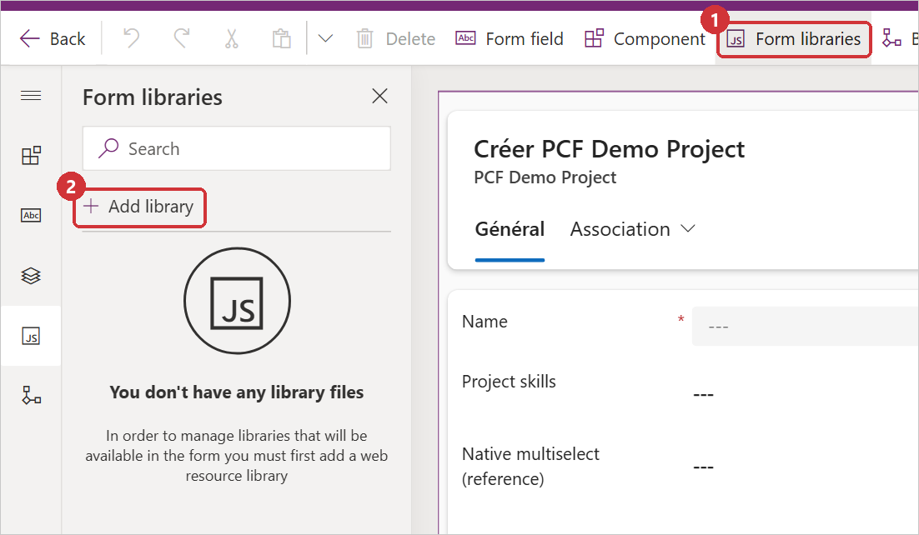
Figure 56. The Form libraries pane.
- Search for NToNMultiSelect (1), select N:N Multi-Select form loader (2), then Add (3).
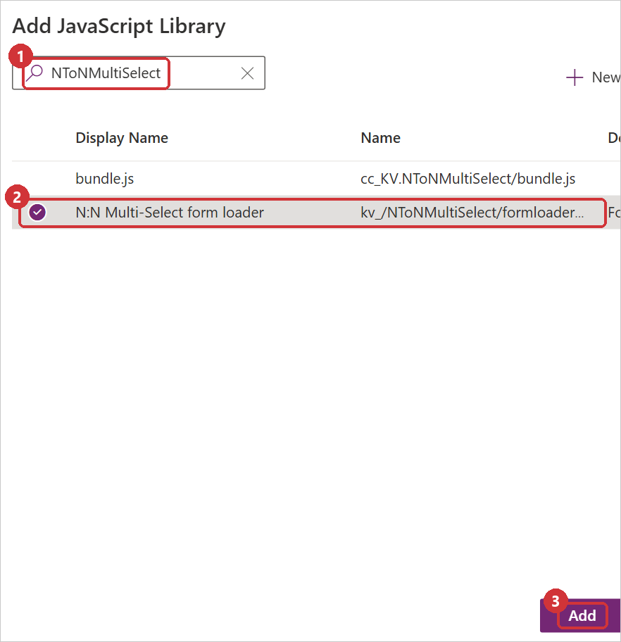
Figure 57. Add JavaScript Library.
- The library is listed in the Form libraries pane.
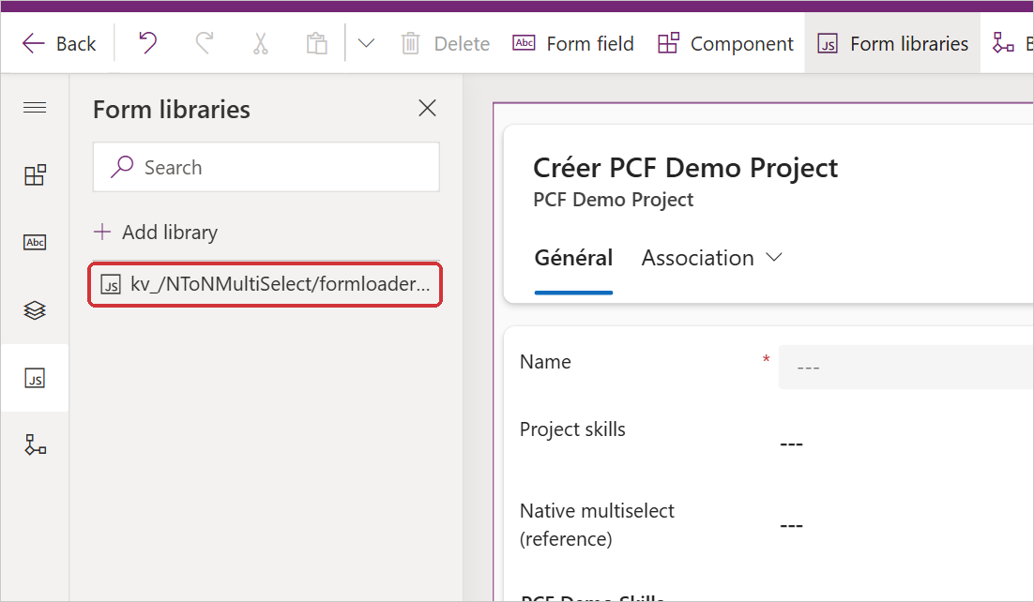
Figure 58. The form library added to the form.
- Select the form itself (an empty area of the form), open the Events tab in the properties pane (1) and select + Event Handler (2).
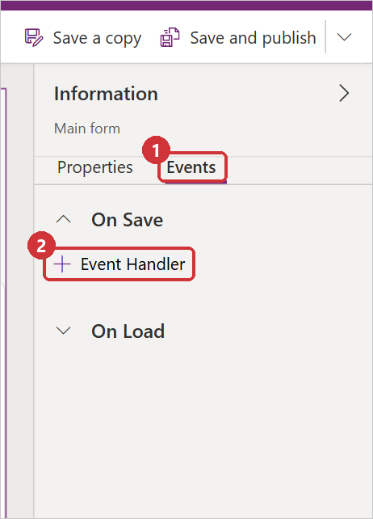
Figure 59. Events of the form.
- In Configure Event, set Event Type to On Load (1), Library to kv_/NToNMultiSelect/formloader.js (2), Function to KVNToNMultiSelectLoader.onLoad (3), tick Enabled and Pass execution context as first parameter (4), and enter the logical name of the host column in single quotes, for example 'ntn_relationshippicker', under Comma separated list of parameters (5). Several host columns are separated with commas. Select Done (6).
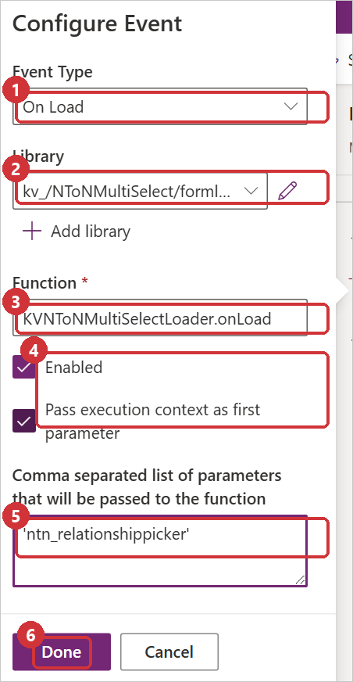
Figure 60. The On Load event handler.
- The Events tab shows one handler.
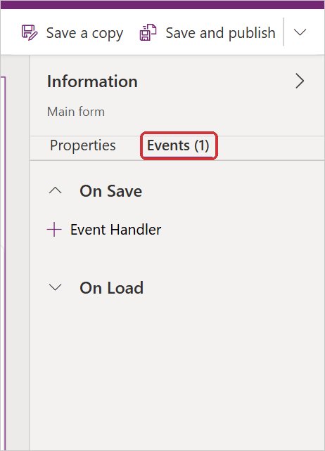
Figure 61. The handler is registered.
- Select Save and publish (figure 23), then reload the record in the app.
Parameters. Without parameters, the library retries every control on the form that failed to load. With the host column names, it retries only those.

7.4 Removing the form library
- Open the form in the form designer. On the form's Events tab, open the On Load handler KVNToNMultiSelectLoader.onLoad and delete it.
- In Form libraries, remove kv_/NToNMultiSelect/formloader.js.
- Select Save and publish.

8. Security and permissions
Action | Privileges needed
See the selected records and the list | Read on the form's table and on the related table
Select and remove records | Append and Append To on both tables
+ New | Create on the related table
Copy names into the host column | Write on the form's record

- The control works with the signed-in user's own session and security roles. Users only see and link records they have access to. When a privilege is missing, the control becomes read-only or names the missing privilege.
- All requests go to the Dataverse Web API of the same environment. External service usage is turned off in the manifest, and the control loads no code from other sites.
- Names are rendered as text, never as HTML. Values sent to the server are escaped for OData and FetchXML.
- The control keeps no data in browser storage.
- Rules about which records may be linked (view, filters, maximum selections) are applied by the control. Subgrids, imports and integrations do not use them. Where a rule must always hold, enforce it on the server, for example with a plug-in on Associate.

9. Upgrading
- Raise the version in control/NToNMultiSelect/ControlManifest.Input.xml, for example to 1.0.1. The build stamps the same number into the solution (1.0.1.0) and the form library.
- Run node scripts/build.mjs.
- Import the new package over the installed solution, the same kind as before (managed over managed, unmanaged over unmanaged). After an unmanaged import, select Publish all customizations.
Always raise the version. Dataverse does not replace a code component when a solution with the same control version is imported; the old bundle stays in place. Users may need to reload the app (Ctrl+F5) to receive the new version.

10. Uninstalling
Dataverse refuses to delete a component while a form still uses it, so the control is removed from the forms first. Uninstalling does not change data: the links stay in the relationship, and text in host columns stays as it is.

10.1 Remove the control from the forms
- On each form that uses the control, open the form in the form designer and select the host column. Under Components, open the menu (⋮) of N:N Multi-Select and select Delete. Use the menu of the component, not Delete on the command bar, which removes the whole column from the form.
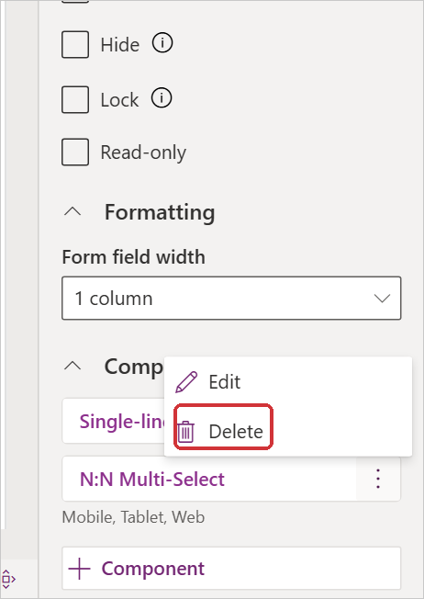
Figure 62. Delete the component from the column.
- The column is back to the standard text box.
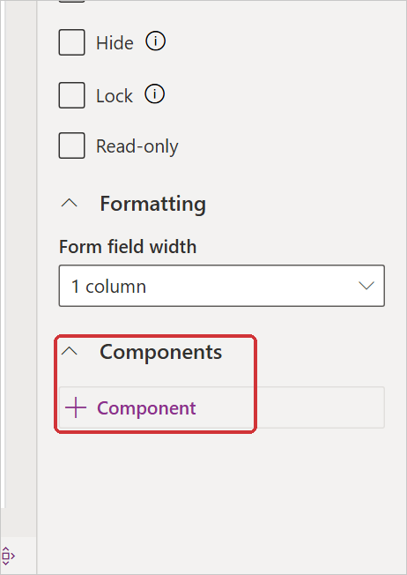
Figure 63. The component removed.
- If the form library was added, remove its On Load handler and the library (section 7.4).
- Select Save and publish. Repeat for every form. To find the forms, open the solution, select the code component and choose Advanced → Show dependencies.

10.2 Uninstall the managed solution
- In Solutions, select Managed (1) and select the N:N Multi-Select row (2).
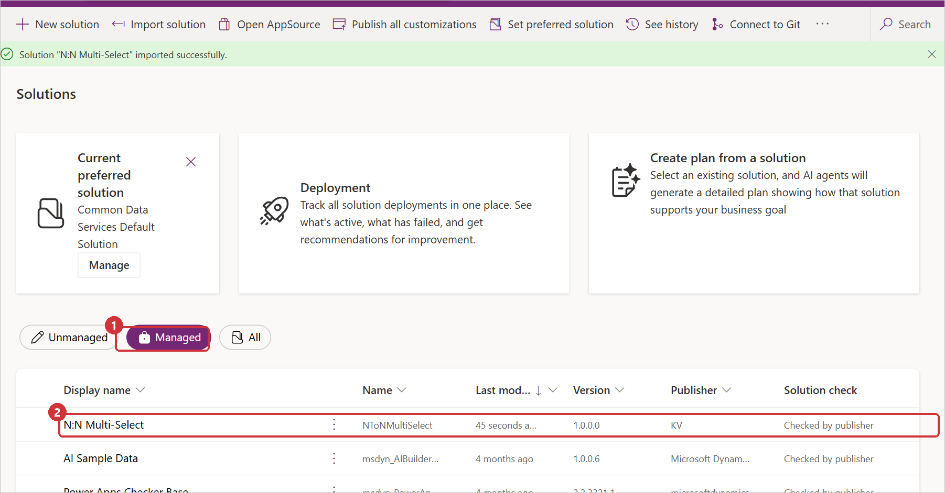
Figure 64. Managed solutions.
- Select Delete on the command bar.
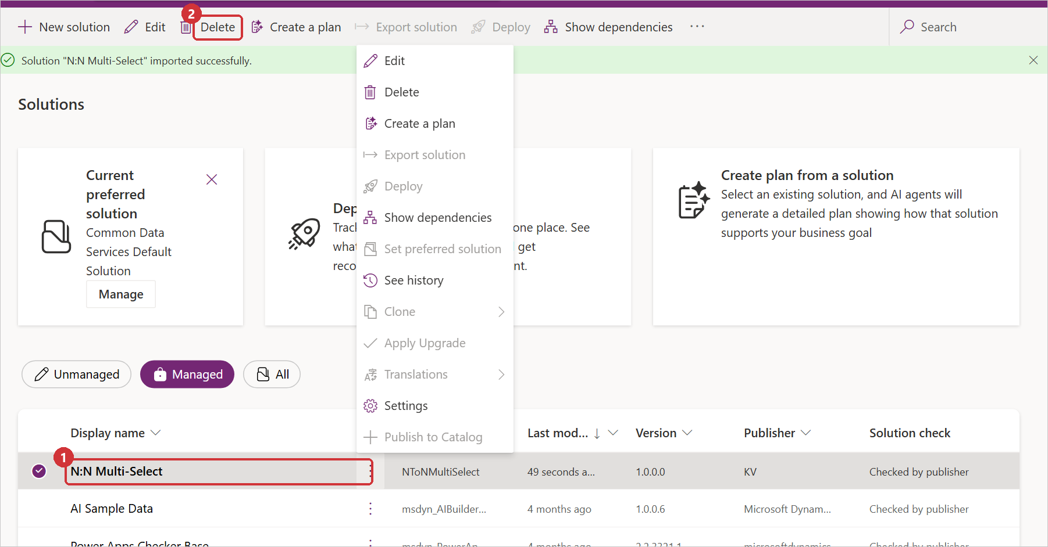
Figure 65. Delete the solution.
- Confirm with Delete. Deleting a managed solution removes the code component and the web resource.
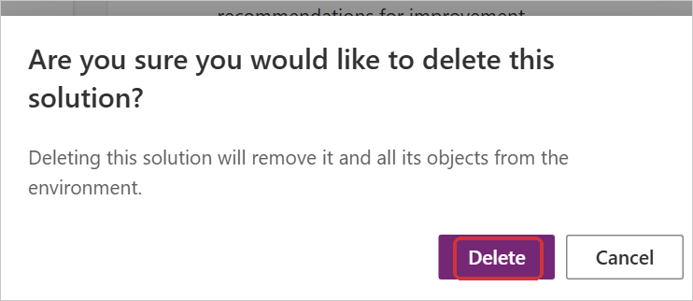
Figure 66. Confirmation.
- When the deletion has finished, a banner confirms it.
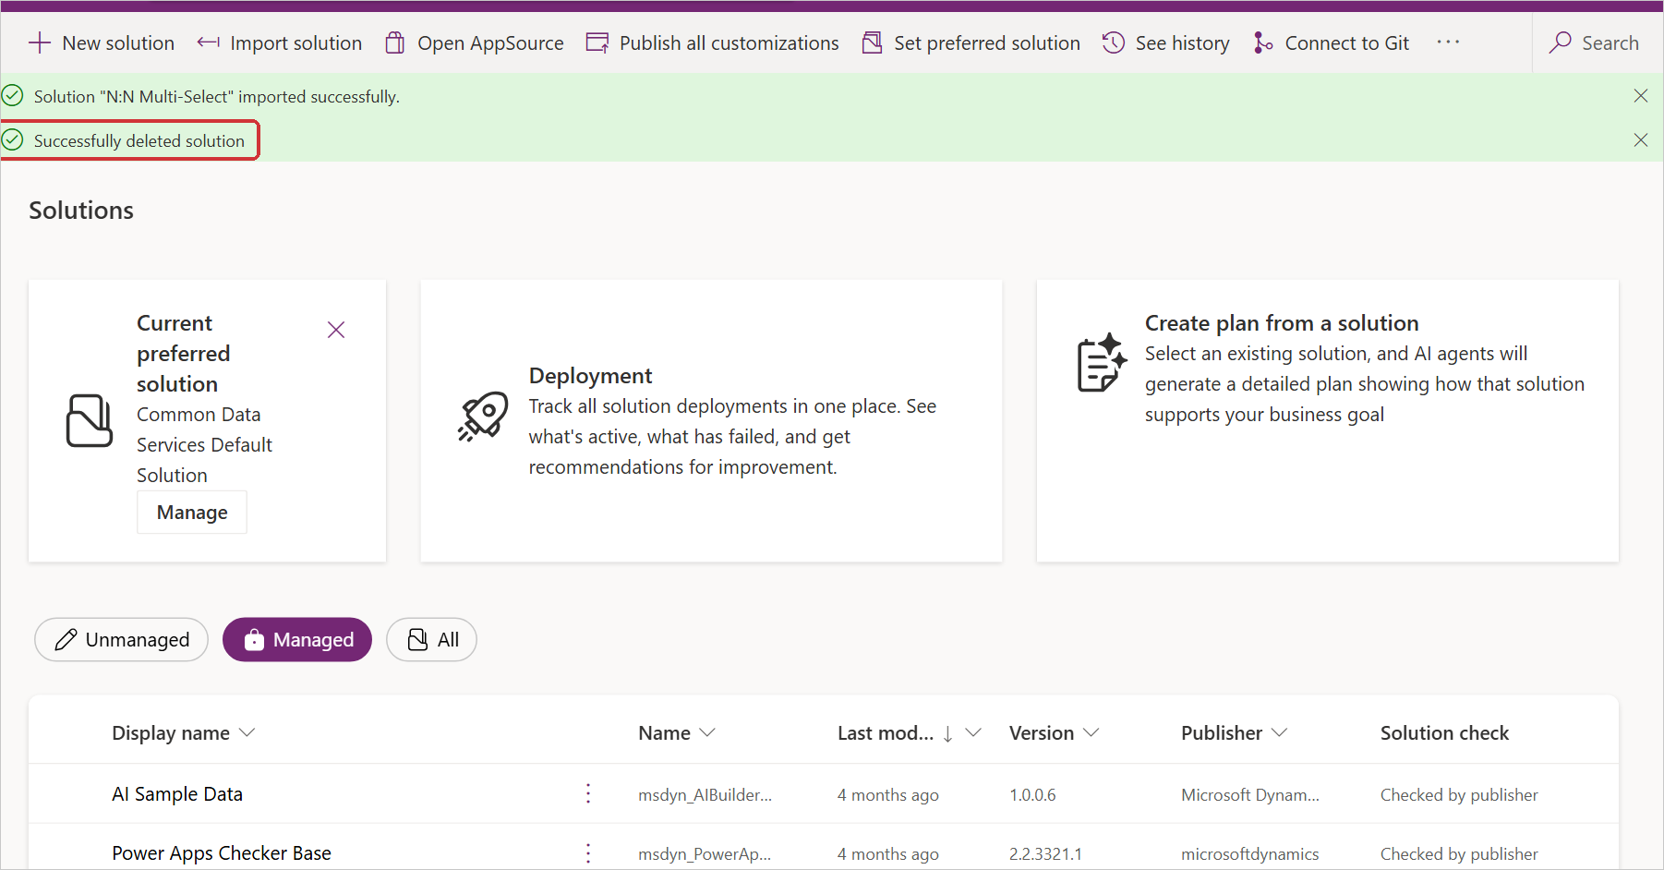
Figure 67. Solution deleted.

10.3 Uninstall the unmanaged solution
Deleting an unmanaged solution removes only the solution record; the components stay in the environment. Delete the components first, then the solution.
- Open the solution and select Objects. Select the custom control kv_KV.NToNMultiSelect (1), then Remove (2) → Delete from this environment (3). Remove from this solution would keep the component in the environment.
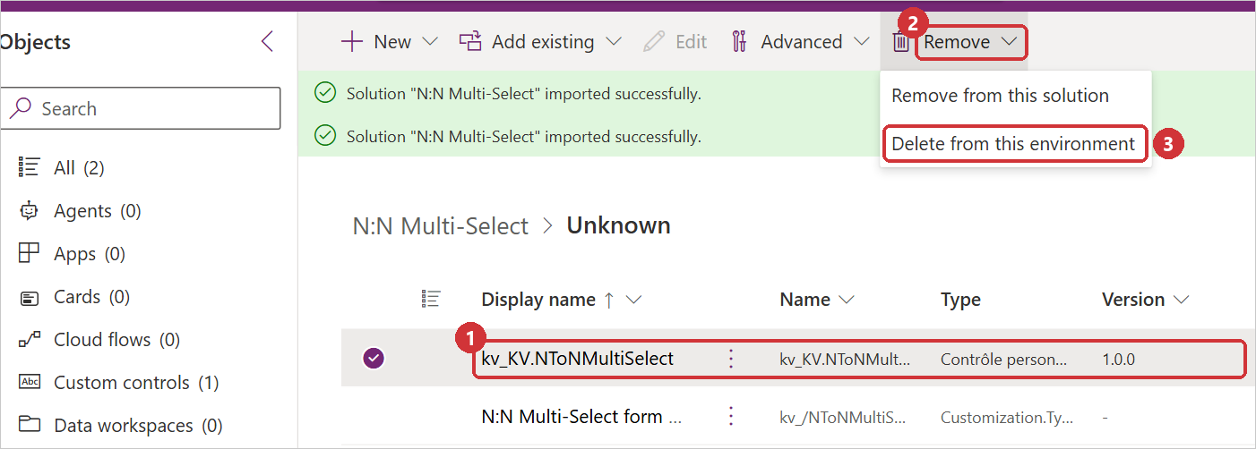
Figure 68. Delete the code component from the environment.
- Confirm with Delete.
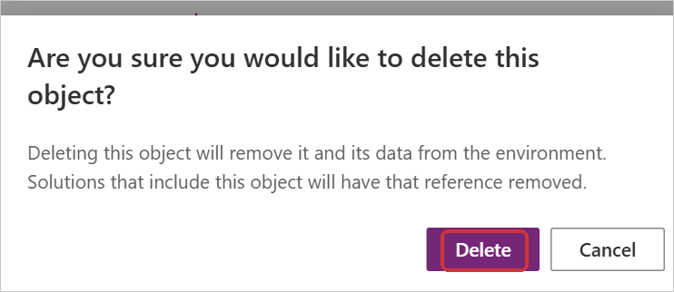
Figure 69. Confirmation.
- Repeat for the web resource N:N Multi-Select form loader (kv_/NToNMultiSelect/formloader.js).
- Go back to Solutions, select N:N Multi-Select and select Delete. The message confirms that only the solution record is deleted.
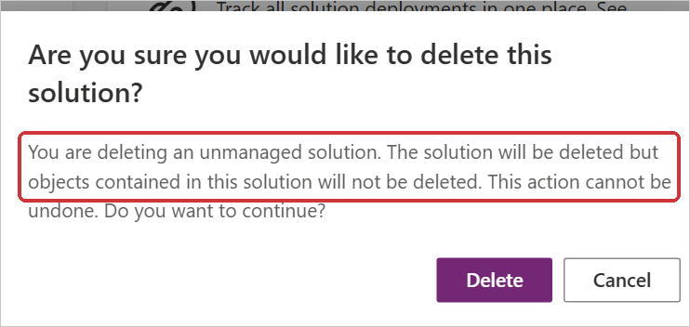
Figure 70. Deleting an unmanaged solution.
- Select Publish all customizations.
The publisher of the solution stays in the environment and can be deleted separately when no other solution uses it.

11. Troubleshooting
Symptom | Cause and solution
"Error loading control"; the console shows "Could not find/invoke ... constructor" | The environment did not deliver the control's bundle. Add the form library (section 7).
The control is not listed in Add component | The solution is not imported or not published. For an unmanaged import, select Publish all customizations. Then use Get more components (section 4.2, step 4).
An older version of the control or form still shows | The browser cached it. Reload with Ctrl+F5. If that is not enough, press F12 → Application → Storage → Clear site data, then reload (this signs the user out of that site).
An update made no difference | The control version was not raised, so Dataverse kept the old bundle (section 9).
"... is not a many-to-many relationship of ..." | The schema name is wrong or belongs to another table. The message lists the valid names.
A view is not found, or is reported as translated | Enter the view's id instead of its name (section 5.4).
The form cannot be saved while the field is empty | The host column is Business required. Use a column that is not required.
"You don't have permission ..." with a privilege name | The user's security role lacks that privilege (section 8).
The + New button does not appear | Quick create is not enabled for the related table, or Maximum selections is reached (section 5.8).
The view column (Copy names) is empty for older records | The copy is written when a record's selection changes. Fill older records once (section 5.6).
The list offers records it should not | Check Records from view, FetchXML filter and Extra OData filter (section 5.3). A view's definition is read once per page load; reload the app after changing it.
"Can't reach the server" or "The server is busy" when the form opens | The control could not start. It tries again after 30 seconds and when the connection comes back; reloading the form also retries.
Subgrids are not refreshed or hidden in a dialog | Expected: in dialogs and side panes the control saves changes but leaves the subgrids alone (section 5.5).

12. Limitations
Area | Limitation
Where it runs | Model-driven app forms (browser, phone and tablet). It cannot be used in canvas apps, Power Pages, views or editable grids.
Relationships | Native many-to-many (N:N) relationships only, one per control. A many-to-many link built from a custom table and two one-to-many relationships is not supported.
Rules | The view, the filters, Show inactive records and Maximum selections apply only in this control. Subgrids, imports, flows, integrations and the Web API can still link any record (section 13.2).
Names copy | Copy names into the host column follows only changes made with this control and with subgrids on the same form. Records linked elsewhere, or before the setting was turned on, keep their old text until their selection changes here. The text is cut to the column's length, includes only the records the editing user can see, and can be read by anyone who can read the record (sections 5.6 and 13.1).
Saving | Each pick is saved immediately. Discarding the form's other changes, or closing it without saving, does not undo picks. The host column's value on the form does not change, so business rules and OnChange scripts on it do not run when records are picked.
New records | On new records opened in a dialog or side pane, and on new Appointment, Recurring Appointment and Service Activity records, the control asks for the record to be saved first; records can be picked once it is saved. On quick create forms, which close when they are saved, the control cannot be used to pick.
List | Only the related table's primary name is shown, sorted by name; the columns and sort order of a view are not used. On tables with more than 500 matching records, search matches the start of the name by default.
Select all | Offered only when every matching record is loaded and their number is at most the Select all limit (500 at most). Each record is linked with its own request.
Dialogs and side panes | On saved records, changes are saved, but subgrids of a form opened in a dialog or side pane are not refreshed or hidden.
Offline | In the mobile app's offline mode the field is read-only.
Languages | English and French. Users with another language see English.
Environments | Some environments do not deliver code components to the form; they need the form library (section 7).
Updates | Dataverse ignores an import with the same control version; every update needs a higher version (section 9).

13. Improving the control with a plug-in
The control works without any server code. Two of its limitations come from the fact that it runs in the browser: the names copy only follows changes made on the form, and the rules about which records may be linked only apply in the control. A plug-in on the Dataverse server closes both gaps, because it runs for every link made anywhere: forms, subgrids, imports, flows, integrations and the Web API.
Links are created and removed with the Associate and Disassociate messages. These messages cannot be registered for one table, so a step registered on them runs for every many-to-many link in the environment. The plug-in therefore checks the relationship name first and returns at once for any other relationship, which keeps the cost for other links negligible.

13.1 Keeping the names column exact
This plug-in rebuilds the host column from the current links after every change, so views, search and exports always show the right names. When it is used, set Copy names into the host column to No so that the column is written in one place only, and fill existing records once (for example with a flow).
- Register the assembly with the Plugin Registration Tool (or pac plugin). Add two steps: message Associate and message Disassociate, primary table none, stage PostOperation, execution mode Synchronous (or Asynchronous, if the column may lag a few seconds behind).
- Replace the constants with the names of your relationship, its intersect table (Tables → the table → Relationships → the many-to-many relationship → Relationship table name), the two tables, the host column and its maximum length.
- The plug-in runs as the system user (CreateOrganizationService(null)), so the column holds every linked name. Pass context.UserId instead to keep only the names the editing user can see. A relationship with more than 5,000 links per record needs paging in the query.
using System;
using System.Linq;
using Microsoft.Xrm.Sdk;
using Microsoft.Xrm.Sdk.Query;

// Associate and Disassociate, primary table none, PostOperation.
public class CopyLinkedNames : IPlugin
{
private const string Relationship = "new_project_skill"; // N:N schema name
private const string IntersectTable = "new_project_skill"; // relationship table name
private const string HostTable = "new_project"; // table of the form
private const string HostColumn = "new_projectskills"; // host column
private const string RelatedTable = "new_skill";
private const string RelatedName = "new_name"; // primary name column
private const int MaxLength = 4000; // host column length

public void Execute(IServiceProvider serviceProvider)
{
var context = (IPluginExecutionContext)serviceProvider
.GetService(typeof(IPluginExecutionContext));
if (!context.InputParameters.TryGetValue("Relationship", out object value)
|| !(value is Relationship relationship)
|| !string.Equals(relationship.SchemaName, Relationship,
StringComparison.OrdinalIgnoreCase))
{
return;
}

var target = (EntityReference)context.InputParameters["Target"];
var related = (EntityReferenceCollection)context
.InputParameters["RelatedEntities"];
var hosts = target.LogicalName == HostTable
? new[] { target.Id }
: related.Where(r => r.LogicalName == HostTable).Select(r => r.Id).ToArray();

var factory = (IOrganizationServiceFactory)serviceProvider
.GetService(typeof(IOrganizationServiceFactory));
var service = factory.CreateOrganizationService(null);
foreach (var hostId in hosts)
{
var query = new QueryExpression(RelatedTable);
query.ColumnSet = new ColumnSet(RelatedName);
query.AddOrder(RelatedName, OrderType.Ascending);
var link = query.AddLink(IntersectTable,
RelatedTable + "id", RelatedTable + "id");
link.LinkCriteria.AddCondition(
HostTable + "id", ConditionOperator.Equal, hostId);

var names = service.RetrieveMultiple(query).Entities
.Select(e => e.GetAttributeValue<string>(RelatedName));
var text = string.Join("; ", names);
if (text.Length > MaxLength) text = text.Substring(0, MaxLength);
service.Update(new Entity(HostTable, hostId) { [HostColumn] = text });
}
}
}

13.2 Enforcing the rules on the server
A plug-in on Associate in the PreValidation stage can refuse links that break a rule, such as inactive records, records outside an allowed set, or more than a maximum number of links. The rule then holds for subgrids, imports and integrations as well. When the control is the one making the link, it undoes the pick and shows the plug-in's message under the field, for example: Couldn't add "Security". Only active skills can be linked.
using System;
using System.Linq;
using Microsoft.Xrm.Sdk;
using Microsoft.Xrm.Sdk.Query;

// Associate, primary table none, PreValidation.
public class CheckLinks : IPlugin
{
private const string Relationship = "new_project_skill";
private const string RelatedTable = "new_skill";

public void Execute(IServiceProvider serviceProvider)
{
var context = (IPluginExecutionContext)serviceProvider
.GetService(typeof(IPluginExecutionContext));
if (!context.InputParameters.TryGetValue("Relationship", out object value)
|| !(value is Relationship relationship)
|| !string.Equals(relationship.SchemaName, Relationship,
StringComparison.OrdinalIgnoreCase))
{
return;
}

var factory = (IOrganizationServiceFactory)serviceProvider
.GetService(typeof(IOrganizationServiceFactory));
var service = factory.CreateOrganizationService(null);
var target = (EntityReference)context.InputParameters["Target"];
var related = (EntityReferenceCollection)context
.InputParameters["RelatedEntities"];
var records = related.Concat(new[] { target })
.Where(r => r.LogicalName == RelatedTable);
foreach (var record in records)
{
var row = service.Retrieve(RelatedTable, record.Id, new ColumnSet("statecode"));
if (row.GetAttributeValue<OptionSetValue>("statecode").Value != 0)
{
throw new InvalidPluginExecutionException(
"Only active skills can be linked.");
}
}
}
}

Both plug-ins are optional. The control keeps working the same way with or without them.

Appendix A. All texts in English and French
The control shows its texts in French for users whose Dynamics language is French (France, Canada, Belgium, Switzerland, Luxembourg or Monaco) and in English for everyone else. Words in braces are filled in when the text is shown: {name} is a record's name, {field} the field's label, {count}, {hidden} and {max} are numbers, {table} and {related table} are table names, and {reason} is one of the reasons in A.5 or the message returned by Dataverse (for example a plug-in's message).

A.1 Field and list
Where | English | French
Empty search box (the Placeholder setting replaces it) | Select or search options | Sélectionner ou rechercher des options
First row of the list | Select all | Sélectionner tout
Next to Select all | {count} items | {count} éléments
(one) | 1 item | 1 élément
List, while records load | Loading… | Chargement…
List, when nothing matches | No entries found | Aucune entrée trouvée
+ New button ({table}: the related table) | New {table} | Nouveau ({table})
Button that collapses the values | less | moins
A record without a name | (No name) | (Sans nom)
Button that closes a message | Dismiss | Fermer

A.2 Notes
Where | English | French
Under the field, on a new record | Your selections are linked when you save the record. | Vos choix seront liés lorsque vous enregistrerez la fiche.
In the field, where picks need a saved record | Save the record first, then pick values here. | Enregistrez d'abord la fiche, puis choisissez des valeurs ici.
In the list, when Maximum selections is reached | Maximum reached: you can select up to {max} records. | Maximum atteint : vous pouvez sélectionner jusqu'à {max} enregistrements.
(one) | Maximum reached: you can select up to 1 record. | Maximum atteint : vous pouvez sélectionner jusqu'à 1 enregistrement.
At the top of the list while Maximum selections is set and not reached, and under the field when a pick would go over the maximum | You can select up to {max} records. | Vous pouvez sélectionner jusqu'à {max} enregistrements.
(one) | You can select up to 1 record. | Vous pouvez sélectionner jusqu'à 1 enregistrement.
Under the field, offline | Not available while you're offline. | Non disponible hors connexion.
In the field, outside a model-driven form | This control can only be used on a model-driven form. | Ce contrôle ne peut être utilisé que sur un formulaire d'application pilotée par modèle.

A.3 Problems while loading or saving
Where | English | French
List | Couldn't load records. | Impossible de charger les enregistrements.
List, after scrolling | Couldn't load more records. Scroll to try again. | Impossible de charger plus d'enregistrements. Faites défiler pour réessayer.
List, after typing | Search failed. | La recherche a échoué.
Field | Couldn't load the selected values. | Impossible de charger les valeurs sélectionnées.
Field, after a failure that needs a reload | Reload the form to try again. | Rechargez le formulaire pour réessayer.
Under the field | Couldn't add "{name}". | Impossible d'ajouter « {name} ».
Under the field | Couldn't remove "{name}". | Impossible de retirer « {name} ».
Under the field | Couldn't save {count} changes. | Impossible d'enregistrer {count} modifications.
Under the field (+ New) | Couldn't create the record. | Impossible de créer l'enregistrement.
Under the field (+ New) | "{name}" was created but couldn't be linked here. Pick it from the list. | « {name} » a été créé, mais n'a pas pu être lié ici. Sélectionnez-le dans la liste.
Under the field (+ New) | "{name}" was created, but it is not one of the records this field offers, so it was not selected. | « {name} » a été créé, mais comme il ne fait pas partie des enregistrements proposés par ce champ, il n'a pas été sélectionné.
App notification, after the record was closed | {count} changes to {field} couldn't be saved after the form was closed. | {count} modifications de {field} n'ont pas pu être enregistrées après la fermeture du formulaire.
(one) | 1 change to {field} couldn't be saved after the form was closed. | Une modification de {field} n'a pas pu être enregistrée après la fermeture du formulaire.
Under the field (Copy names into the host column) | The names could not be copied into {field}: {reason} | Les noms n'ont pas pu être copiés dans {field} : {reason}

A.4 Settings that cannot work
Where | English | French
Field | Set the N:N relationship schema name in the control properties. | Indiquez le nom de schéma de la relation N:N dans les propriétés du contrôle.
Field | "{relationship}" is not a many-to-many relationship of {table}. Check the relationship schema name in the control properties. Many-to-many relationships on {table}: {relationship}, .... | « {relationship} » n'est pas une relation N:N de la table {table}. Vérifiez le nom de schéma de la relation dans les propriétés du contrôle. Relations N:N de la table {table} : {relationship}, ....
Field | Relationship "{relationship}" links {table 1} and {table 2}; it cannot be used on a {table} form. | La relation « {relationship} » lie les tables {table 1} et {table 2}. Elle ne peut pas être utilisée sur un formulaire de la table {table}.
Field | Table {table} has no primary name column, so its records cannot be listed. | La table {table} n'a pas de colonne de nom principal. Ses enregistrements ne peuvent donc pas être listés.
List | The extra OData filter can't be combined with a view or a FetchXML filter. Put the condition in the FetchXML filter instead. | Le filtre OData supplémentaire ne peut pas être combiné avec une vue ou un filtre FetchXML. Placez plutôt la condition dans le filtre FetchXML.
List | A complete FetchXML query can't be combined with a view. Use one of them, or narrow the view with <filter> and <link-entity> elements only. | Une requête FetchXML complète ne peut pas être combinée avec une vue. Utilisez l'une ou l'autre, ou limitez la vue avec des éléments <filter> et <link-entity> seulement.
List | The FetchXML filter isn't well-formed XML: {detail} | Le filtre FetchXML n'est pas un XML bien formé : {detail}
List | The FetchXML filter must be a complete <fetch> query, or <filter> and <link-entity> elements. | Le filtre FetchXML doit être une requête <fetch> complète, ou des éléments <filter> et <link-entity>.
List | The FetchXML query is for the table {table}, but this relationship links {related table} records. | La requête FetchXML porte sur la table {table}, alors que cette relation lie des enregistrements de {related table}.
List | An aggregate FetchXML query can't list records to pick. | Une requête FetchXML d'agrégation ne peut pas lister des enregistrements à sélectionner.
List | There is no active view "{view}" for the table {table}. Views of this table and their ids: {view} ({id}), .... | Aucune vue active « {view} » n'existe pour la table {table}. Vues de cette table et leurs identifiants : {view} ({id}), ....
List | "{view}" is a translated view name, which differs from one language to another. Enter the id of the view instead: {id}. | « {view} » est un nom de vue traduit, qui change d'une langue à l'autre. Indiquez plutôt l'identifiant de la vue : {id}.
List | The view "{view}" belongs to the table {table}, but this relationship links {related table} records. Choose a view of {related table}. | La vue « {view} » appartient à la table {table}, alors que cette relation lie des enregistrements de {related table}. Choisissez une vue de {related table}.
List | The query is too long to send to the server. Shorten the filters of the view or the FetchXML filter. | La requête est trop longue pour être envoyée au serveur. Raccourcissez les filtres de la vue ou le filtre FetchXML.

A.5 Reasons added to a problem
Where | English | French
No connection | Can't reach the server. Check your connection and try again. | Impossible de joindre le serveur. Vérifiez votre connexion et réessayez.
No answer in time | The server took too long to respond. | Le serveur a mis trop de temps à répondre.
Throttling (service protection limits) | The server is busy. Try again in a minute. | Le serveur est occupé. Réessayez dans une minute.
Signed out | Your session has expired. Refresh the page and try again. | Votre session a expiré. Actualisez la page et réessayez.
Missing privilege for links | You don't have permission to change these related records. | Vous n'avez pas l'autorisation de modifier ces enregistrements associés.
Missing privilege to read | You don't have permission to see these related records. | Vous n'avez pas l'autorisation d'afficher ces enregistrements associés.
Missing privilege to update the record | You don't have permission to change this record. | Vous n'avez pas l'autorisation de modifier cet enregistrement.
Search too expensive on a very large table | This search is too slow for this table. Search by the first letters of the name. | Cette recherche est trop lente pour cette table. Recherchez par les premières lettres du nom.

A.6 Screen reader texts and tooltips
Where | English | French
Name of a field without a label | Related records | Enregistrements associés
Name of the list of values | Selected values for {field} | Valeurs sélectionnées pour {field}
Description of the field | {count} selected: {name 1}, {name 2} | {count} éléments sélectionnés : {name 1}, {name 2}
(one) | 1 selected: {name} | 1 élément sélectionné : {name}
(none) | Nothing selected | Aucune sélection
Name of the chevron button | Show options | Afficher les options
Name of a value's × button | Remove {name} | Retirer {name}
Tooltip of a value's link | Open {name} in a new tab | Ouvrir {name} dans un nouvel onglet
Name of the +N button | +{hidden}, show all {count} selected values | +{hidden}, afficher les {count} valeurs sélectionnées
Name of the less button | Show less | Afficher moins de valeurs sélectionnées
A value highlighted with the keyboard | {name}. Press Delete or Backspace to remove, arrow keys to move. | {name}. Appuyez sur Suppr ou Retour arrière pour le retirer, sur les flèches pour vous déplacer.
Same, with Open selected records | {name}. Press Enter to open, Delete or Backspace to remove, arrow keys to move. | {name}. Appuyez sur Entrée pour l'ouvrir, sur Suppr ou Retour arrière pour le retirer, sur les flèches pour vous déplacer.
Announcement | {name} selected | {name} : sélectionné
Announcement | {name} removed | {name} : retiré
Announcement (Select all) | All {count} items selected | Les {count} éléments sont sélectionnés
(one) | 1 item selected | 1 élément sélectionné
Announcement (Select all) | All {count} items removed | Les {count} éléments ont été retirés
(one) | 1 item removed | 1 élément retiré

